TABLE OF CONTENTS
CHAPTER NO | TOPIC | PG. NO
CHAPTER 1: | INTRODUCTION  1.1 Overview  1.2 Scope of the Project  1.3 Study of Existing System | 1 - 8
CHAPTER 2: | SYSTEM ANALYSIS  2.1 Proposed System  2.1.1 Defining the Problem  2.1.2 Developing Solution Strategies  2.1.3 Flow Diagrams  2.2 System Specification  2.2.1 Functional Requirements  2.2.2 Non-Functional Requirements  2.2.3 Hardware Specifications  2.2.4 Software Specifications | 9 - 24
CHAPTER 3: | SOFTWARE DESIGN  3.1 Overview of System Design  3.2 Database Design  3.3 Coding  3.4 Reports Generated | 25 - 75
CHAPTER 4: | TESTING & STRATEGIES  4.1 Techniques used in Testing  4.2 Test Cases  4.3 Types of testing Conducted  4.4 Test Case Examples | 76 - 82
CHAPTER 5: | SCREENSHOTS | 83 - 89
CHAPTER 6: | CONCLUSIONS & REFERENCES  6.1 Conclusion  6.2 References  6.3 Appendices | 90 - 100

INTRODUCTION

An Overview
- Darkwave is a self-hosted Open-Source Capture The Flag (CTF) platform designed for cybersecurity enthusiasts, students, and professionals looking to test and enhance their security skills. With the increasing demand for practical cybersecurity training, Darkwave provides an engaging and versatile environment for both learning and competition. This platform is intended for individuals and teams, enabling them to explore a wide range of security challenges in various categories, from web exploitation and cryptography to reverse engineering, binary exploitation, and forensics.
- Aimed at both educational institutions and corporate training programs, Darkwave provides a comprehensive solution for hosting CTF competitions. It offers a secure and controlled environment where users can participate in challenges designed to simulate real-world cybersecurity scenarios. Each challenge is crafted to test the knowledge and skills of participants while offering a rewarding experience through the process of solving puzzles and capturing flags.
- The Darkwave platform is designed with a modular approach, allowing easy expansion and integration of new challenges, making it adaptable for various user needs. The challenges are categorized into different difficulty levels to cater to diverse skill sets, providing a well-rounded experience from beginners to advanced users. As participants progress through the platform, they can track their performance, compare their scores with others, and compete in team-based events, promoting both individual growth and collaborative learning.

Key Features of Darkwave:
- Diverse Challenge Categories: The platform hosts challenges across a wide array of cybersecurity domains, including:
- Web Exploitation: Challenges focused on exploiting vulnerabilities in web applications.
- Cryptography: Tasks involving encryption, decryption, cryptographic protocols, and algorithms.
- Reverse Engineering: Problems designed to test knowledge of low-level programming, assembly language, and code analysis.
- Binary Exploitation: Challenges that require participants to exploit memory management vulnerabilities such as buffer overflows and format string vulnerabilities.
- Forensics: Tasks related to data analysis, network traffic analysis, and recovering data from corrupted files or systems.
- Interactive User Interface: Darkwave provides a user-friendly interface for both participants and administrators. The interface includes easy registration, user dashboards for tracking progress, leaderboards for real-time competition, and intuitive challenge submission forms.
- Real-Time Scoring System: A dynamic scoring system that updates in real time, offering immediate feedback to participants as they submit correct flags. This encourages active engagement and competition during events.
- Challenge Management and Customization: The platform includes an administrative dashboard that enables organizers to create, deploy, and manage challenges efficiently. Challenges can be customized with varying levels of difficulty, and hints can be provided to assist participants in their problem-solving process.
- Security and Data Integrity: Darkwave is built with security best practices in mind, ensuring the integrity of the platform and the challenges. User authentication is secured through encryption, and challenges are sandboxed to prevent system vulnerabilities from being exploited during the competition.
- Deployment Flexibility: The platform can be deployed in both local environments and cloud-based infrastructures, allowing organizations to host events without worrying about scalability or resource management. It is also containerized for easy deployment and isolation of individual challenges.

Educational and Competitive Focus
- The Darkwave platform is not only intended for individual practice but also serves as a tool for organizing large-scale cybersecurity competitions. Whether it is for universities, cybersecurity training programs, or corporate environments, the platform provides a structured and secure environment to test and enhance participants' cybersecurity knowledge. Administrators can host events ranging from small-scale internal training exercises to large public competitions.
- Additionally, Darkwave can be integrated with educational resources, offering detailed analysis and breakdowns of completed challenges. This provides a rich learning experience, where users can review their solutions, understand the vulnerabilities they exploited, and improve their cybersecurity knowledge base.

Future Expansion
While Darkwave currently offers a robust set of features for CTF events, it is designed to be highly extensible. Future enhancements might include:
- Automated Flag Validation: To improve the challenge-solving experience, automatic validation of flags based on custom algorithms could be introduced.
- Containerized Challenge Environments: Isolating each challenge in a virtualized container or environment ensures both security and performance optimization. (present scope includes non-container environments)
- Integration with Online Training Platforms: Partnering with cybersecurity learning platforms could provide users with additional resources and tutorials related to challenges on Darkwave.
- More Advance dynamic challenges: Challenges focused on exploiting vulnerabilities in web applications, such as SQL injection, cross-site scripting (XSS), and cross-site request forgery (CSRF).
- In essence, Darkwave is not just a CTF platform; it is a comprehensive educational and competitive environment that seeks to contribute to the growth of the cybersecurity community by offering a powerful, interactive, and scalable solution for cybersecurity challenges.

Scope of the Project
The Darkwave CTF platform is designed to be a flexible and comprehensive solution for organizing and participating in Capture the Flag (CTF) events. The platform is divided into several core components that make up the overall experience, ranging from user management to challenge creation and scoring systems. The following sections provide a more detailed overview of each component and its role in the platform.
1. User Management System
The User Management System is at the heart of the platform, allowing users to register, log in, and interact with the system in a secure and personalized manner.
- Registration & Authentication: The system provides a secure registration process where users can create accounts with basic personal details, such as usernames, emails, and passwords. Authentication is handled through encryption, ensuring that user data is protected. Two-factor authentication (2FA) could is introduced to add an additional layer of security.
- User Roles: The platform supports multiple user roles, such as:
  - Participant: Regular users who participate in challenges, track their progress, and view leaderboards.
  - Administrator: Users with higher privileges who can create and manage challenges, monitor platform activity, and ensure security.
- User Dashboard: Each user is given a personalized dashboard that provides an overview of their activity, including challenges they've participated in, flags they've captured, and scores. The dashboard serves as a central hub for managing user progress, viewing hints, and receiving notifications about new challenges or events.
2. Challenge Management
The Challenge Management System is designed to enable administrators to easily create, deploy, and manage cybersecurity challenges across various categories and difficulty levels.
- Challenge Creation: Administrators can create custom challenges using a web-based interface. Each challenge is categorized by type (e.g., Web Exploitation, Cryptography, Reverse Engineering), and administrators can assign a difficulty level, time limit, and point value to each challenge.
  - Challenge Types: Challenges can range from simple puzzles to complex real-world security problems, such as reverse engineering binary executables, exploiting SQL injection vulnerabilities, or cracking encrypted files.
  - Challenge Difficulty: Each challenge can be marked with varying difficulty levels (easy, medium, hard) to cater to different experience levels. This allows for a more structured learning experience and ensures that users are appropriately challenged.
- Dynamic Challenge Deployment: Challenges can be deployed dynamically, allowing administrators to activate or deactivate them in real time based on the event's schedule. This makes it easy to organize timed competitions or rotating sets of challenges.
- Hint System: To assist users in solving particularly difficult challenges, a hint system is implemented. Hints can be made available at specific intervals, and participants can use them to gain insights into how to approach a solution. The hint system is customizable, allowing administrators to control the number and timing of hints.
- Challenge Isolation: Each challenge is run in a sandboxed environment, meaning that it operates independently from the rest of the system, ensuring that participants cannot affect other challenges or access unauthorized data. This isolation maintains the integrity of the platform and minimizes the risk of malicious activity.
3. Scoring and Ranking System
The Scoring and Ranking System ensures that participants are accurately and fairly rewarded based on their performance in solving challenges.
- Real-Time Scoring: The platform uses an automated scoring system that updates in real time as participants submit flags. Once a flag is correctly submitted, the system verifies it, allocates the appropriate points, and updates the participant’s score accordingly.
- Leaderboards: A leaderboard displays the scores of all participants (or teams) and ranks them based on their performance. This feature creates a competitive atmosphere, motivating participants to solve challenges more efficiently and quickly. Leaderboards can be filtered by individual or team performance and can be set up for public or private events.
- Time-Based Scoring: In competitive CTF events, time is often a critical factor. Darkwave’s scoring system can be configured to factor in the time taken to solve challenges. Faster flag submissions are rewarded with more points, ensuring that participants are incentivized to complete challenges efficiently.
- Flag Validation: To ensure the integrity of the event, the system validates flags using secure algorithms. The system checks each submitted flag against the expected correct answer and prevents cheating through automated flag verification methods. Flags are only accepted if they meet specific criteria defined by the challenge creator.
4. Security and Integrity
Security is a critical aspect of any CTF platform, and Darkwave incorporates several measures to protect both users and the system itself.
- User Authentication & Data Protection: All user data is encrypted and securely stored in the database. Strong password hashing algorithms and encryption protocols are used to protect sensitive information, ensuring that even if the database is compromised, user data remains secure.
- Challenge Sandboxing: Each CTF challenge is executed within a sandboxed environment to ensure that it does not interfere with the platform's underlying infrastructure. This also ensures that challenges are isolated, meaning that any exploits or vulnerabilities within a challenge do not compromise the integrity of other challenges or the platform itself.
- System Monitoring: Real-time monitoring tools track system activity, including user actions, challenge submissions, and event status. This allows administrators to identify and prevent any suspicious behavior or potential exploits.
- Prevention of Cheating: The platform includes safeguards to detect and prevent common cheating methods, such as brute-forcing flag submissions, tampering with challenge data, or exploiting system vulnerabilities. This ensures a fair and secure environment for all participants.
5. Reporting and Analytics
The Reporting and Analytics system allows both participants and administrators to gain insights into event progress and performance.
- Event Reports: Administrators can generate reports on event participation, scoring, and challenges. These reports are useful for reviewing the event's success and identifying areas for improvement in future CTFs.
- User Performance Analytics: Detailed analytics provide insights into individual and team performance, including challenge completion rates, most frequently solved challenges, and areas where users faced difficulties. This can be used to tailor future events to the needs of participants.
- Exportable Data: Administrators can export event results and user data in various formats (e.g., CSV, PDF) for documentation or further analysis.
6. Deployment and Scalability
Darkwave is designed to be scalable and flexible, ensuring that it can handle events of all sizes, from small local competitions to large, international CTF events.
- Cloud and On-Premise Deployment: The platform can be deployed on cloud infrastructure, such as AWS or Google Cloud, or hosted on private servers for internal events. Cloud deployment ensures scalability and resource flexibility, while on-premise deployment provides more control over the infrastructure.
- Extensibility: The platform is designed to be extensible, allowing developers to add new features, integrate with external tools, and support additional challenge types or integrations with other platforms.

Study of Existing System
The global cybersecurity and CTF (Capture The Flag) community has grown rapidly over the years, supported by platforms that help organize events, create challenges, and engage learners. Well-known platforms like CTFd, RootTheBox, FBCTF, and PicoCTF have been instrumental in running competitions and training both students and professionals in cybersecurity. These platforms let users attempt security-related challenges in areas like cryptography, web exploitation, reverse engineering, and more. However, despite their popularity, they tend to fall short in specific areas—especially when it comes to accessibility, customization, and educational focus for users from developing regions like India.
Existing Platforms and Their Gaps
- CTFd
CTFd is one of the most popular open-source platforms used for hosting CTF competitions. It allows organizers to create and manage challenges, scoreboards, and users easily. However, it offers limited features out-of-the-box for secure challenge deployment or educational progress tracking. Custom features often require technical knowledge or third-party plugins, which can be a barrier for smaller colleges or new organizers.
- RootTheBox
RootTheBox offers a gamified experience and includes unique features like in-game currency, player avatars, and customizable scoring. However, its setup can be overly complex and may not suit newer organizers or academic institutions that want a straightforward, educational-focused experience.
- FBCTF
Originally developed by Facebook, FBCTF introduced a visually interactive map-based interface. While unique, it’s no longer actively maintained and has become difficult to deploy or extend. It also lacks support for newer challenge types and modern security learning tools.
- Common Limitations Across Platforms
Most current CTF platforms do not fully address the needs of Indian institutions, small learning groups, or developers from low-infrastructure regions. Some of the most noticeable limitations include:
- Lack of built-in cybersecurity learning tools: Most platforms focus only on challenge solving but do not offer learning paths, hints, or security concepts that help users understand why a solution works.
- No regional customization: Language support, low-bandwidth optimization, or mobile-first designs are mostly ignored—making it hard to use these platforms in Tier 2 or Tier 3 cities in India.

Darkwave: Closing the Gaps
Darkwave is built to address these specific issues. It is not just a CTF hosting platform—it is an accessible, secure, and education-oriented system designed with Indian learners, developers, and educators in mind.
While other systems focus mostly on challenge delivery, Darkwave includes features that promote both learning and safe practice. It offers challenge sandboxing through containers, real-time scoring, team dashboards, and optional hints with explanations. Each challenge can be aligned with OWASP top 10 concepts, allowing users to connect problems to real-world cybersecurity risks.

SYSTEM ANALYSIS

2.1. Proposed System
- The proposed system, Darkwave, is a modern, web-based platform designed to advance cybersecurity education and practical skills through gamified Capture The Flag (CTF) challenges. Darkwave targets the Indian academic and tech community, providing a secure, scalable, and accessible environment for hosting, managing, and participating in CTF competitions. It bridges the gap between traditional theoretical learning and real-world cybersecurity problem-solving, making it ideal for students, professionals, and institutions alike.

- Darkwave enables event organizers and educators to design and deploy challenges across categories such as web exploitation, cryptography, binary exploitation, reverse engineering, forensics, and OSINT. Each challenge can include descriptive metadata like difficulty level, category, scoring system, author name, and hints. Admins can set up events that are timed or untimed, public or private, and manage teams or individuals via a unified event dashboard.

- A standout feature of Darkwave is its security-first design philosophy. Unlike generic CTF platforms that overlook infrastructural vulnerabilities, Darkwave implements OWASP-compliant design across the board—from secure file handling and flag submissions to session management and role-based access. Challenge environments are containerized using Docker, ensuring isolation and protection from lateral movement or privilege escalation. These measures make the platform suitable for secure, multi-user deployments in academic settings and corporate environments.

- The system incorporates role-based access control (RBAC) to define user permissions based on their function. Roles include Admins (full access), Challenge Creators (content upload), Moderators (activity oversight), Mentors (learner guidance), and Participants (challenge solvers). This structure prevents privilege abuse and enables decentralized event management across institutions or teams.

- Darkwave also features a Developer Dashboard, where creators can upload, test, and preview challenges using a guided UI. They can attach Docker images, assign tags, configure scoring rules, and embed educational content such as learning outcomes or related OWASP vulnerabilities. Once reviewed, these challenges are published into the challenge bank, available for selection in any new event.

- Darkwave includes a Learning and Resources Hub where users can access beginner-to-advanced content on cybersecurity concepts, writeups, tutorials, and walkthroughs. This not only builds context around challenge types but also aligns with certification paths such as CEH, OSCP, and CISSP, making it an educational asset in classroom or training environments.

- The system also supports analytics and reporting. Event organizers and moderators can view challenge solve statistics, flag submission histories, time-to-solve metrics, and user activity logs. These tools help identify top performers, detect suspicious behaviour (e.g., flag sharing), and refine challenge difficulty.

- Accessibility is a core concern addressed by Darkwave. The platform is optimized for low-bandwidth environments and mobile compatibility, allowing students from rural or semi-urban regions to participate without performance issues. Features such as asset compression, lazy loading, and light/dark UI modes enhance usability across devices.

The frontend offers an intuitive interface for users to:
- Browse and filter challenges by category or difficulty.
- View event rules, timelines, and updates.
- Engage in limited social interactions (comments, team chat).
- Track their performance history, badges, and team rankings.

- On the administrative side, Darkwave provides comprehensive dashboards for managing users, content, and events. Moderators can approve or reject new challenges, respond to abuse reports, disable accounts, and review analytics to ensure fair play and quality control.

- Furthermore, Darkwave includes developer and participant profiles where individuals can showcase their challenge contributions, certifications, and solve history. This acts as a public portfolio that can be referenced for internships, job opportunities, or community recognition.

- In summary, Darkwave is not just a CTF competition engine—it is a full-fledged cybersecurity learning ecosystem. By combining secure infrastructure, gamified learning, analytics, role-based management, and regional accessibility, the platform empowers Indian learners and educators to explore, engage, and excel in the field of ethical hacking and cybersecurity.

2.1.1. Defining the Problem
- In the current digital landscape, cybersecurity is a critical concern across industries, yet practical cybersecurity education remains inaccessible or ineffective for a vast segment of students and aspiring professionals—especially in regions like India where infrastructure, resources, and mentorship are limited. Traditional academic programs often emphasize theory over practice, leaving learners underprepared for real-world scenarios like ethical hacking, penetration testing, or incident response.
- Capture The Flag (CTF) competitions have emerged globally as a dynamic and gamified way to learn cybersecurity. However, most existing CTF platforms—whether open-source or commercial—suffer from a range of limitations when viewed from an Indian context:
Key Problems Identified:
- Lack of Regional Relevance:
  - Most platforms are not optimized for local bandwidth constraints or Indian payment systems.
  - Language, documentation, and UX often assume Western infrastructure and audiences.
- No Educational Focus:
  - Existing CTF platforms rarely offer structured learning paths, feedback loops, or resources to support beginners.
  - There's no integration with academic syllabi or certification tracks like CEH, OSCP, or CompTIA Security+.
- Security Concerns:
  - Many CTF setups expose users to insecure challenge environments, lack sandboxing, and use improper flag validation methods.
  - Platforms fail to implement core OWASP guidelines, leaving them vulnerable to abuse or exploitation.
- Poor Challenge Management:
  - Current platforms do not provide intuitive dashboards for challenge creation, tagging, testing, or version control.
  - No support for Docker container isolation or modular challenge deployments.
- Administrative Difficulties:
  - Managing events, monitoring user behavior, generating analytics, or moderating content is cumbersome or entirely absent in many solutions.

2.1.2. Developing Solution Strategies
To address the problems identified in the previous section, Darkwave is designed with a user-first and security-first approach. The platform integrates modern web technologies, secure development practices, and a gamified learning structure tailored specifically for Indian learners and institutions. Below are the strategic approaches used to solve the challenges:

- Localization and Accessibility Strategy
- Regional Optimization: Design the UI/UX with support for low-bandwidth connections and mobile-friendly interfaces. Features like lazy loading, asset compression, and offline access to challenges ensure better reach in Tier 2/3 cities.
- Payment Gateway Integration: Integrate Indian payment systems such as UPI, Paytm, and RuPay for paid events or donations instead of payment methods like PayPal, Patreon so on and so forth
- Security-Centric Architecture
- OWASP Compliance: Follow OWASP top 10 security principles throughout the platform to secure authentication, challenge access, session handling, and file uploads.
- Rate Limiting & Brute-force Protection: Apply rate limits, and automated abuse detection to secure login and submission endpoints.

- Educational Focus
- Learning Tracks: Provide curated challenge paths for different difficulty levels and topics (e.g., Web, Forensics, Crypto, Reverse Engineering).
- In-Platform Resources: Embed tutorials, hints, and walkthroughs that explain not only how to solve a challenge but also the underlying vulnerability.
- Progression & Certification: Allow users to earn badges, certificates, and ranks to validate their learning and track improvement over time.

- Robust Challenge & Event Management
- Challenge Builder Interface: Offer a web-based dashboard for admins to create, categorize, tag, test, and schedule CTF challenges easily.
- Flag Handling & Validation: Use regex patterns, encrypted flags, and secure APIs to validate submissions without exposing sensitive logic.

- User Management and Community Features
- Role-Based Access Control (RBAC): Define clear access levels for participants, moderators, administrators, and event hosts.
- User Profiles and Portfolios: Allow users to showcase their completed challenges, earned badges, and skill levels publicly or privately.

- Admin and Moderation Tools
- Analytics Dashboard: Provide insights on user behavior, challenge popularity, performance metrics, and system health.
- Content Moderation: Give moderators tools to approve or reject challenges, review user reports, and manage flagged content.
- Backup & Recovery: Implement scheduled data backups and failure recovery procedures to ensure platform reliability.
- Scalability and Deployment
- Modular Microservices: Break down core features (user service, challenge service, scoring engine, etc.) into independent modules for easier maintenance and scaling.
- Cloud Ready: Support deployment on cloud services like AWS, Azure, or Indian cloud providers.

2.1.3. Flow Diagrams
To understand how the Darkwave platform operates internally, it is essential to visualize its key workflows and component interactions. This section includes two major types of flow diagrams:
- Data Flow Diagram (DFD) – Level 1
- System Architecture Diagram

1. Data Flow Diagram (Level 1)
The following DFD provides a high-level view of how data moves through the Darkwave system from various user interactions:
Entities:
- User (Player / Learner)
- Admin
- Moderator
- Challenge Creator
Processes:
- User Registration & Login
- Challenge Access & Attempt
- Flag Submission & Scoring
- Challenge Creation & Review
- Admin Moderation
Data Stores:
- User Database
- Challenge Database
- Submission Logs
- Leaderboard Database
- Hint Logs

Data Flow Diagrams
`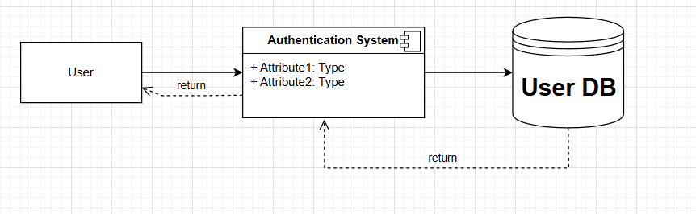
Fig.2.1 Authentication & Authorization

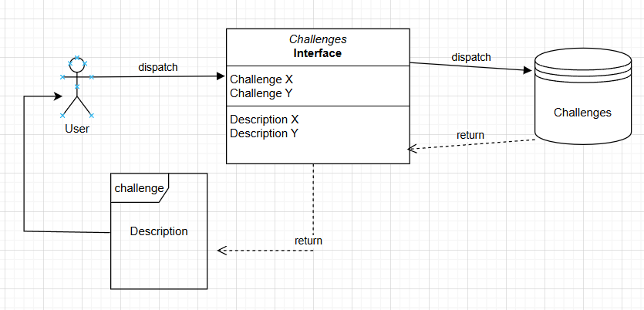
Fig.2.2 Fetching of Challenges

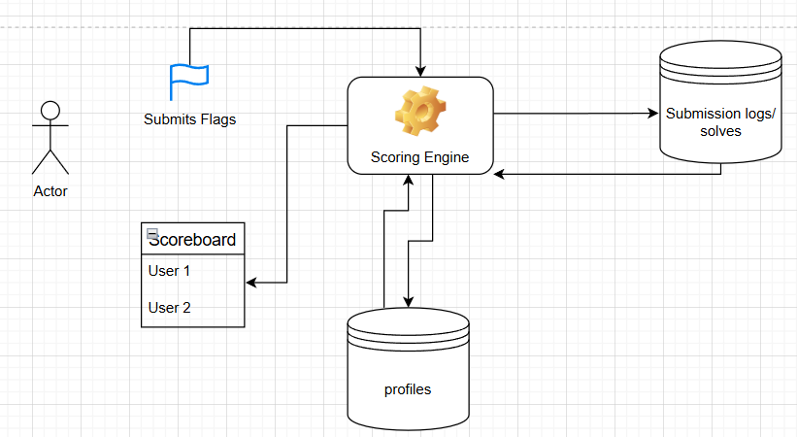
Fig.2.3 Flag Submission
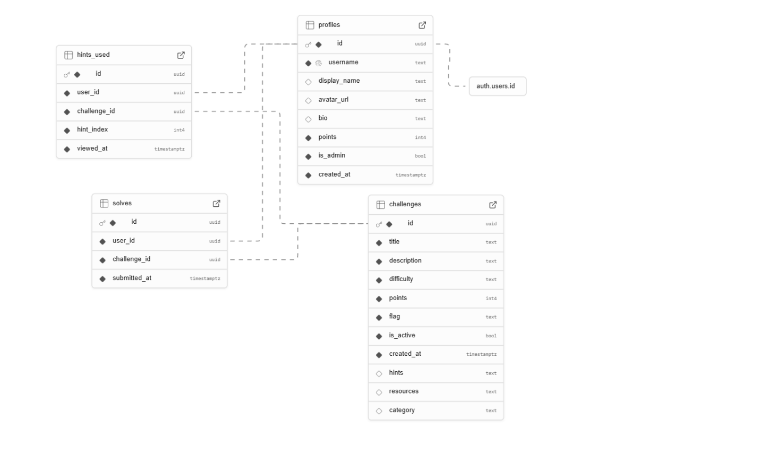
Fig 2.4 Database

Database Schema Breakdown
Entities and Attributes
- Profiles (Users)
- id: Primary key
- username: Unique identifier for login
- display_name: Name shown to other users
- avatar_url: URL to profile picture
- bio: User description
- points: Total points earned
- is_admin: Boolean flag for admin privileges
- created_at: Timestamp of account creation
- Challenges
- id: Primary key
- title: Name of the challenge
- description: Details about the challenge
- difficulty: Level of challenge (easy/medium/hard)
- points: Reward for solving
- flag: Correct solution/answer
- is_active: Whether challenge is available
- created_at: When challenge was added
- hints: Available hints (likely JSON array)
- resources: Related materials (likely JSON array)
- category: Challenge type/category
- Solves (Completion Records)
- id: Primary key
- user_id: Foreign key to profiles
- challenge_id: Foreign key to challenges
- submitted_at: When challenge was solved
- Hints Used (Hint Tracking)
- id: Primary key
- user_id: Foreign key to profiles
- challenge_id: Foreign key to challenges
- hint_index: Which hint was viewed
- viewed_at: When hint was accessed
- Relationships
- One-to-Many:
  - One profile can have many solves
  - One profile can use many hints
  - One challenge can be solved by many users
  - One challenge can have its hints viewed by many users
- Many-to-Many (implied through junction tables):
  - Users to Challenges through Solves
  - Users to Challenges through Hints_Used

2.2. System Specification
The System Specification section describes the detailed requirements, functionalities, and constraints for the Darkwave platform. It focuses on providing a comprehensive overview of how the system will operate and what components are necessary for successful implementation. This section includes functional requirements, non-functional requirements, and hardware/software specifications.

2.2.1 Functional Requirements
The functional requirements define the core behaviors and features that the platform must support:
- User Authentication & Authorization
- The platform will support secure sign-up and login functionalities using Firebase Authentication.
- Role-based access will be implemented:
  - Admin: Full control over game approvals, moderation, and platform management.
  - Developer: Upload and manage games, access cybersecurity resources, and edit profiles.
  - Gamer: Browse games, leave reviews, rate games, and engage in multiplayer sessions.
- Developer Dashboard
- Developers will have access to a dedicated dashboard to:
  - Upload and manage game listings (title, genre, description, trailer, screenshots).
  - Track approval status from admins.
  - Access feedback from reviews and ratings.

- Game Distribution & User Interaction
- Users will be able to:
  - Browse games by genre, platform (2D/3D), and ratings.
  - Play games in-browser (if supported) or download them.
  - View trailers and screenshots.
  - Leave reviews and participate in multiplayer or community events.

- Cybersecurity Awareness Hub
- The platform will include a Cybersecurity Awareness section for both gamers and developers:
  - Access to blogs, tutorials, and videos on security best practices.
  - Developers can learn about securing game code, preventing vulnerabilities, and optimizing performance.
- Admin Panel & Content Moderation
- Admins will:
  - Approve or reject games based on predefined quality and security criteria.
  - Remove inappropriate content (e.g., offensive reviews or harmful uploads).
  - Monitor platform-wide activity for potential threats or misuse.
- Review & Rating System
- Users can:
  - Post reviews and assign ratings to games.
  - Flag inappropriate or misleading content.
- Developers can view ratings and feedback to improve their games.
- Data Security & Storage
- Sensitive user data will be securely stored using Firebase with encryption protocols.
- Game files, images, and media will be stored on cloud-based services (e.g., Google Cloud Storage or AWS S3).
- The system will conform to OWASP Top 10 security guidelines.
- Advanced Search & Filtering
- Users will be able to search and filter games by:
  - Genre, Rating, Popularity, Release Date, Platform Type, etc.
- Notification System
- All users will receive real-time notifications for:
  - Game status updates (approvals, rejections).
  - Replies to reviews or platform messages.
  - System-generated alerts (e.g., new game uploads or updates).

2.2.2. Non-Functional Requirements
These requirements define quality and performance metrics for the platform:
1. Performance
- Page load and browsing actions must respond in under 2 seconds.
- Capable of supporting 100,000+ concurrent users.
- Game assets should load within 3–5 seconds.
2. Scalability
- System must scale horizontally with demand (adding servers, users, games).
- Easily extendable to support new features or integrations.
3. Reliability
- Target uptime of 99.9%.
- Regular backups and disaster recovery protocols will be enforced.
4. Security
- Multi-layered security implementation:
  - OAuth2.0 + JWT for authentication.
  - Secure file uploads with malware checks.
  - TLS/SSL encryption for all communications.
  - Protection against XSS, CSRF, and SQL injection.
5. Usability
- Clean, intuitive UI with responsive layouts.
- Support for both dark and light modes.
- Fully optimized for desktop and mobile users.
6. Localization
- Supports multiple Indian languages (Hindi, Tamil, Kannada, etc.).
- Language auto-detected via location with manual override in settings.
7. Compliance
- Compliance with GDPR, Indian IT Act, and regional privacy laws.
- Security development aligned with OWASP best practices.

2.2.3 Hardware Specifications

For Development & Testing
- Processor: Intel i5 (8th Gen+) or equivalent, multi-core recommended.
- RAM: 8 GB or more.
- Storage: 512 GB SSD minimum.
- Internet: 10 Mbps+ speed.
- Graphics: Integrated graphics; dedicated GPU if developing high-end games.
- OS: Windows 10, Ubuntu LTS, or macOS.

For Production Deployment
- Cloud Servers: AWS EC2, GCP Compute Engine, or Azure VMs.
- Intel Xeon or equivalent multi-core processors.
- RAM: 16 GB or more.
- Storage: SSD with 1 TB or more; scalable via cloud storage (S3, GCS).
- Backup: Automated cloud-based backups.
- OS: Ubuntu Server or other Linux-based OS.

2.2.4 Software Specifications
- Frontend
- React: Component-based UI with efficient rendering (Virtual DOM).
- TypeScript: Strong typing for reduced bugs and improved developer experience.
- CSS3 / SCSS: Modular and responsive design with mobile-first approach.
- State Management: Redux or React Context API for handling global state.
- Backend
- Supabase:
  - PostgreSQL as the primary database for structured game and user data.
  - Real-time capabilities for instant updates (notifications, reviews, approvals).
  - Built-in authentication and role-based authorization.
- Authentication:
  - Email/password and OAuth options (Google, GitHub).
  - JWT for secure session handling.
- File Storage:
  - Supabase or cloud storage for user-uploaded content (trailers, screenshots, game files).
- APIs & Server Logic:
- Supabase Edge Functions (serverless):
  - Handle backend logic for game uploads, email notifications, and data interactions.
- GraphQL (optional):
    - Efficient, client-specific data querying supported by Supabase.
- Security:
- Supabase Security Rules: Role-based access control.
- SSL/TLS: Secure communications.
- CORS: Configured to allow only trusted origins.
- Real-time Features
- Live updates for:
  - Game approvals, reviews, ratings.
  - Multiplayer activity and system messages.
- Version Control & Collaboration
- GitHub:
  - Code versioning, issue tracking, and collaborative development.
  - CI/CD via GitHub Actions for automated testing and deployment.
- Testing & Deployment
- Jest: Unit testing for JavaScript logic.
- React Testing Library: Component-level UI testing.
- CI/CD Pipelines: Automated builds, tests, and deployments for a streamlined development cycle.
This section outlines the technical specifications required to develop, deploy, and run the Darkwave platform effectively. It includes both hardware and software requirements, categorized by the perspective of developers, users (participants), and server infrastructure.

SOFTWARE DESIGN
This chapter describes the architectural and design decisions that define the structure and interaction between components in the Darkwave platform. The design emphasizes modularity, scalability, security, and user experience to support real-time CTF competitions.

3.1 Overview of System Design
Darkwave is a Capture The Flag (CTF) platform tailored to enhance the learning and competitive experience of cybersecurity enthusiasts. The platform is designed with a focus on accessibility, scalability, and usability. Using the Lovable Design methodology, the system is structured to provide intuitive user flows and a robust backend system that ensures a seamless and secure experience for all users.

3.1.1. Design Methodology: Design Approach
The Design methodology emphasizes the importance of creating systems that are both functional and delightful to use. This user-centric approach integrates empathy and emotional resonance into every aspect of the design. It balances technical precision with user experience, ensuring that the platform not only meets functional requirements but also delivers a positive and engaging experience for the users.
- Empathy and User Focus: Design decisions in Darkwave prioritize the needs and pain points of the users, particularly CTF participants, organizers, and admins. The system interfaces, security measures, and performance optimizations are all tailored to provide maximum usability.
- Iterative Development: Darkwave follows an iterative development process, continuously refining features based on user feedback. This ensures that the platform evolves with the needs of its users while maintaining flexibility for improvements.
- Emotional Engagement: To engage users, the design considers elements like friendly UI, intuitive interactions, and a streamlined challenge interface. The goal is to create an experience that not only works well but also feels rewarding and fun.

3.1.2 Architectural Design
The architectural design of Darkwave focuses on scalability, modularity, and fault tolerance. It is built with a microservices architecture to ensure that individual components of the platform can evolve independently without disrupting the system’s core functionality.
- Key components of the architecture include:
- Frontend: Built using React.js, ensuring a responsive and dynamic interface. It uses React Router for seamless navigation between different sections like the challenge dashboard, user profile, and leaderboard.
- Backend: Node.js (Express) or Python (Flask/FastAPI) powers the server-side logic, with RESTful APIs for communication between the frontend and backend. The backend is responsible for user management, challenge handling, session tracking, and notifications.
- Database: PostgreSQL or MongoDB, depending on the data structure complexity. PostgreSQL will be used for structured data like user profiles, challenge scores, and leaderboard stats, while MongoDB may be used for unstructured data (e.g., user-submitted flags or logs).
- File Storage: For challenge files, media, and user-generated content, AWS S3 or MinIO provides secure and scalable storage. These systems ensure easy retrieval and management of game data.
- Authentication: Secure user authentication is handled using JWT (JSON Web Tokens), providing role-based access control for participants, challenge creators, and admins.
- Real-Time Updates: WebSockets or Supabase’s real-time features will be used to push live updates to users, such as score changes, new challenge uploads, or progress tracking.

3.1.3 UI/UX Design
A key principle in Lovable Design is that user experience should be intuitive and enjoyable. The UI/UX of Darkwave was designed with the following objectives:
- Simple & Clean Interface: Minimalist design with clear information hierarchy. Users can easily navigate through ongoing challenges, scoreboards, and user profile sections without being overwhelmed by unnecessary details.
- Engaging Challenge Design: The CTF challenges are designed to be visually engaging, with clear instructions, time tracking, and progress indicators. This motivates users to engage more actively and efficiently.
- Mobile-First Design: Given the global nature of CTF participants, the platform is fully responsive, ensuring usability across both desktop and mobile devices.
- User Feedback & Support: Feedback mechanisms, such as chat support and a forum for community discussion, are integrated into the system. Additionally, users are encouraged to submit feedback on challenges and the platform to help refine future iterations.

3.1.4 Component Design
Each major component of Darkwave has been designed to serve a specific function:
- Challenge Dashboard: For both challenge creators and participants, the challenge dashboard offers a clean view of all active challenges. The creator has tools to manage challenge content, while participants can track their progress and submit flags.
- Leaderboard System: The leaderboard dynamically updates as participants submit flags and gain points. It provides a competitive but fun way for users to track their progress compared to others.
- Security Measures: Special attention has been given to security throughout the platform. The use of SSL/TLS encryption, CSRF protection, and secure file uploads ensures that user data and challenge content remain protected.
- Admin Panel: Admins can manage user accounts, approve or reject challenges, and monitor platform activity to ensure a smooth and secure user experience. Role-based access control ensures that only authorized users have access to specific admin features.

3.1.5 Database Design
The database design is critical for managing user profiles, challenge data, scores, and interactions. The relational database (PostgreSQL) will consist of the following primary tables:
- Users: Stores user information such as name, email, password (hashed), role (participant, creator, admin), and challenge history.
- Challenges: Contains data on challenges, including title, description, difficulty, creation date, and the creator’s ID.
- Scores: Records user progress on each challenge, storing flags submitted and time taken to complete.
- Leaderboards: Tracks overall rankings, updated in real-time as users submit correct flags.

3.1.6 System Integration
Darkwave integrates multiple technologies to ensure efficient data flow and real-time operations:
- Third-Party APIs: For additional functionalities like email notifications (via SendGrid), push notifications, or analytics.
- Continuous Integration/Continuous Deployment (CI/CD): GitHub Actions or Jenkins will automate the build and deployment pipeline, ensuring that the platform can be quickly updated with minimal downtime.
- Containerization: Docker containers will be used for consistent development environments and simplified deployment to cloud infrastructure like AWS or DigitalOcean.

3.1.7 Security and Privacy Considerations
Security is a cornerstone of the platform, especially in CTF environments where the integrity of challenges and user data must be preserved. Darkwave will use a multi-layer security strategy:
- Data Encryption: All sensitive user data (e.g., passwords, personal information) will be encrypted both in transit (via HTTPS) and at rest (using AES encryption).
- Authentication & Authorization: Secure authentication methods, such as JWTs, will be implemented to manage user sessions. Role-based access control will ensure that each user type has the appropriate level of access.
- Regular Security Audits: Regular vulnerability scans and penetration tests will be conducted to identify and mitigate any potential risks.

3.2 Database Design
The database design for Darkwave is crucial for maintaining the integrity, security, and accessibility of data throughout the platform. Given the nature of the CTF environment, the database must support a variety of data types such as user profiles, challenges, submissions, scores, and leaderboard data. Darkwave utilizes a relational database system (PostgreSQL) due to its robustness, scalability, and support for complex queries, along with data integrity features that ensure reliable and secure data management.
Core Entities:
- Users: Stores information about platform users, including their roles (e.g., participant, creator, admin), credentials, and activity history.
- Challenges: Contains all the details related to individual CTF challenges, such as the challenge title, description, category, difficulty level, and associated metadata.
- Submissions: Tracks user submissions for challenges, including the flag, submission time, and the status of the submission (correct/incorrect).
- Scores: Records each user’s score, tied to individual challenges, reflecting their progress and performance.
- Leaderboards: Stores real-time rankings based on challenge completions, allowing for competitive display of user performance.
- Hint: Stores the logs of hints used for more competitiveness

3.3 Coding (Modular Description)
Frontend
The Home Page serves as the landing interface of the Capture The Flag (CTF) platform. It is designed to provide users with a clear overview of the platform, accessible navigation to core features (such as login, registration, challenges, and leaderboard), and a visually appealing layout using modern frontend technologies.
Home page

import React from 'react';
import { Button } from '@/components/ui/button';
import { Shield, Terminal } from 'lucide-react';

// Hero component representing the main landing section of the Darkwave platform
const Hero = () => {
return (
<div className="relative overflow-hidden bg-cyber-black min-h-[80vh] flex items-center">
{/* Cyberpunk grid background and overlay for visual style */}
<div className="absolute inset-0 cyber-grid opacity-20"></div>
<div className="absolute inset-0 bg-gradient-to-t from-cyber-black via-transparent to-transparent"></div>

{/* Container to align content in the center with padding */}
<div className="container mx-auto px-4 sm:px-6 lg:px-8 relative z-10">
<div className="flex flex-col items-center md:items-start text-center md:text-left">

{/* Logo and Title Section */}
<div className="mb-4 flex items-center">
<Shield className="h-12 w-12 text-cyber-blue animate-pulse-neon" />
<h1 className="text-4xl md:text-6xl font-bold ml-4">
<span className="neon-text">Dark</span>
<span className="pink-neon-text">Wave</span>
</h1>
</div>

{/* Subtitle and Description */}
<p className="mt-3 max-w-md mx-auto md:mx-0 md:mt-5 md:max-w-3xl text-base md:text-xl text-gray-300">
Enter the digital battleground. Hack, decrypt, exploit.
<br />
<span className="text-cyber-blue">Prove your skills in our cyberpunk-themed challenges.</span>
</p>

{/* CTA Buttons: Start Hacking and Learn More */}
<div className="mt-10 sm:flex sm:justify-center md:justify-start">
<div className="rounded-md shadow">
<Button className="cyber-button flex items-center text-lg px-8 py-5">
<Terminal className="mr-2 h-5 w-5" />
START HACKING
</Button>
</div>
<div className="mt-3 sm:mt-0 sm:ml-3">
<Button variant="outline" className="cyber-button flex items-center text-lg px-8 py-5 border-cyber-pink hover:bg-cyber-pink">
<Shield className="mr-2 h-5 w-5" />
LEARN MORE
</Button>
</div>
</div>

{/* Statistics Section */}
<div className="mt-20 grid grid-cols-1 md:grid-cols-3 gap-8 max-w-4xl mx-auto md:mx-0">
<StatCard title="100+" description="Unique Challenges" color="blue" />
<StatCard title="5000+" description="Active Hackers" color="pink" />
<StatCard title="24/7" description="CTF Environment" color="purple" />
</div>
</div>
</div>

{/* Decorative Cyberpunk Image (Optional Visual Element) */}
<div className="absolute bottom-0 right-0 w-full md:w-1/2 pointer-events-none opacity-20 md:opacity-40">
<img
src="https://placehold.co/600x400/121212/00FFFF?text=CYBER+NETWORK"
alt="Cyberpunk Network"
className="w-full"
/>
</div>
</div>
);
};

// Reusable StatCard component to display individual stats
const StatCard = ({ title, description, color }: {
title: string;
description: string;
color: 'blue' | 'pink' | 'purple';
}) => {
// Define dynamic color class based on provided color prop
const colorClass = {
blue: 'border-cyber-blue text-cyber-blue',
pink: 'border-cyber-pink text-cyber-pink',
purple: 'border-cyber-purple text-cyber-purple',
}[color];

return (
<div className={`cyber-border bg-cyber-darkgray/50 p-5 ${colorClass}`}>
<h3 className="text-2xl md:text-3xl font-bold">{title}</h3>
<p className="mt-2 text-gray-300">{description}</p>
</div>
);
};

export default Hero;

Navbar
The Navigation Bar (Navbar) is a persistent user interface element displayed at the top of the application across all routes. It serves as the primary means of navigation throughout the CTF platform, providing users with quick access to key pages such as Home, Challenges, Leaderboard, Login, and Profile.
import React, { useState } from 'react';
import { Link, useNavigate } from 'react-router-dom';
import { Button } from "@/components/ui/button";
import {
Shield, Terminal, Trophy, User, Menu, X, LogOut, Settings, Award
} from "lucide-react";
import { useAuth } from '@/contexts/AuthContext';
import {
Sheet,
SheetContent,
SheetTrigger,
} from "@/components/ui/sheet";
import {
DropdownMenu,
DropdownMenuContent,
DropdownMenuItem,
DropdownMenuLabel,
DropdownMenuSeparator,
DropdownMenuTrigger,
} from "@/components/ui/dropdown-menu";

// Navbar component controls site navigation, user account options, and responsive mobile support
const Navbar = () => {
const { user, profile, signOut, isAdmin } = useAuth(); // Auth context to access current user and role
const [mobileOpen, setMobileOpen] = useState(false); // State to manage mobile drawer visibility
const navigate = useNavigate();

// Handles user logout
const handleSignOut = async () => {
await signOut(); // Sign out via context
navigate('/'); // Redirect to homepage
setMobileOpen(false); // Close mobile drawer if open
};

return (
<nav className="bg-cyber-darkgray border-b border-cyber-blue">
<div className="max-w-7xl mx-auto px-4 sm:px-6 lg:px-8">
<div className="flex items-center justify-between h-16">

{/* Logo and Brand Name */}
<Link to="/" className="flex items-center">
<Shield className="h-8 w-8 text-cyber-blue" />
<span className="ml-2 text-xl font-bold">DarkWave</span>
</Link>

{/* Desktop Navigation Menu */}
<div className="hidden md:flex items-center space-x-8">
<Link to="/challenges" className="text-gray-300 hover:text-white">
Challenges
</Link>
<Link to="/scoreboard" className="text-gray-300 hover:text-white">
Scoreboard
</Link>
<Link to="/about" className="text-gray-300 hover:text-white">
About
</Link>

{/* Admin Panel Link - Only visible for admins */}
{isAdmin && (
<Link to="/admin" className="text-purple-400 hover:text-purple-300">
<Settings className="h-5 w-5" />
</Link>
)}

{/* User Dropdown (If logged in) or Auth Buttons (If not) */}
{user ? (
<DropdownMenu>
<DropdownMenuTrigger asChild>
<Button variant="ghost" className="flex items-center gap-2">
<User className="h-5 w-5" />
<span>{profile?.username || 'Profile'}</span>
</Button>
</DropdownMenuTrigger>
<DropdownMenuContent className="w-56">
<DropdownMenuLabel>My Account</DropdownMenuLabel>
<DropdownMenuSeparator />
<DropdownMenuItem asChild>
<Link to="/profile" className="w-full">
Profile
</Link>
</DropdownMenuItem>
<DropdownMenuItem onClick={handleSignOut}>
Log out
</DropdownMenuItem>
</DropdownMenuContent>
</DropdownMenu>
) : (
<div className="flex space-x-4">
<Link to="/auth">
<Button variant="outline">Login</Button>
</Link>
<Link to="/auth?tab=signup">
<Button>Register</Button>
</Link>
</div>
)}
</div>

{/* Mobile Menu Button - Visible only on small screens */}
<div className="md:hidden">
<Sheet open={mobileOpen} onOpenChange={setMobileOpen}>
<SheetTrigger asChild>
<Button variant="ghost" size="icon">
<Menu className="h-6 w-6" />
</Button>
</SheetTrigger>

{/* Mobile Drawer Content */}
<SheetContent side="right" className="w-[300px]">
<div className="flex flex-col h-full pt-6">

{/* Display user avatar/initials and info */}
{user && profile && (
<div className="flex items-center space-x-3 mb-6">
<div className="w-10 h-10 rounded-full bg-cyber-blue/20 flex items-center justify-center">
<span className="text-xl font-bold">
{profile.username?.charAt(0).toUpperCase()}
</span>
</div>
<div>
<div className="font-medium">{profile.username}</div>
<div className="text-sm text-cyber-green">
{profile.points} pts
</div>
</div>
</div>
)}

{/* Navigation Links in Drawer */}
<nav className="flex-1 space-y-4">
<Link
to="/challenges"
className="block py-2"
onClick={() => setMobileOpen(false)}
>
Challenges
</Link>
<Link
to="/scoreboard"
className="block py-2"
onClick={() => setMobileOpen(false)}
>
Scoreboard
</Link>
<Link
to="/about"
className="block py-2"
onClick={() => setMobileOpen(false)}
>
About
</Link>

{/* Admin Access Link in Mobile */}
{isAdmin && (
<Link
to="/admin"
className="block py-2 text-purple-400"
onClick={() => setMobileOpen(false)}
>
Admin Panel
</Link>
)}Admin Panel
</Link>
)}
</nav>

<div className="mt-auto pb-8">
{user ? (
<Button
variant="destructive"
className="w-full"
onClick={handleSignOut}
>
Sign Out
The Sign Out (Logout) functionality allows authenticated users to securely terminate their session on the platform. It ensures that once a user logs out, all personalized features such as the Profile page, flag submissions, and leaderboard tracking are disabled until the user logs in again.
</Button>
) : (
<div className="space-y-3">
<Link to="/auth">
<Button className="w-full">Login</Button>
</Link>
<Link to="/auth?tab=signup">
<Button variant="outline" className="w-full">
Register
</Button>
</Link>
</div>
)}
</div>
</div>
</SheetContent>
</Sheet>
</div>
</div>
</div>
</nav>
);
};

export default Navbar;

About
The About Page provides users with an overview of the CTF platform, its purpose, features, and the technologies used to build it. It helps establish trust, clarify goals, and guide new users on how to engage with the platform.
import React from 'react';
import Navbar from '@/components/Navbar';
import Footer from '@/components/Footer';
import { Shield, Terminal, Code, Bug } from 'lucide-react'; // Icons used for visual sections

// Main About component
const About = () => {
return (
<div className="bg-cyber-black min-h-screen">
{/* Navigation bar at the top */}
<Navbar />

{/* Hero Section with Title and Brief Description */}
<div className="py-12 bg-cyber-darkgray border-b border-cyber-blue">
<div className="container mx-auto px-4">
<h1 className="text-4xl font-bold mb-4">
ABOUT DarkWave<span className="pink-neon-text">CTF</span>
</h1>
<p className="text-gray-300 max-w-3xl">
A next-generation CTF platform with a cyberpunk aesthetic, designed for hackers of all skill levels.
</p>
</div>
</div>

{/* Content Section: Main About Info */}
<div className="container mx-auto px-4 py-16">
<div className="max-w-4xl mx-auto">

{/* Mission Section */}
<section className="mb-16">
<div className="flex items-center mb-6">
<Terminal className="text-cyber-blue h-6 w-6 mr-3" />
<h2 className="text-2xl font-bold">OUR MISSION</h2>
</div>
<p className="text-gray-300 mb-4">
DarkWave was created to provide a challenging yet accessible platform for cybersecurity enthusiasts to hone their skills.
In a world increasingly dependent on digital infrastructure, we believe that practical hands-on experience is the best way to learn security concepts.
</p>
<p className="text-gray-300">
Our challenges cover various areas of cybersecurity including web exploitation, cryptography, reverse engineering, binary exploitation, and forensics.
Each challenge is designed to teach specific concepts that are relevant in the real world of cybersecurity.
</p>
</section>

{/* How It Works Section */}
<section className="mb-16">
<div className="flex items-center mb-6">
<Code className="text-cyber-pink h-6 w-6 mr-3" />
<h2 className="text-2xl font-bold">HOW IT WORKS</h2>
</div>
<p className="text-gray-300 mb-4">
Darkwave hosts various challenges across different categories of cybersecurity. Each challenge contains a "flag" - a specific string that you need to discover by solving the challenge.
</p>
<p className="text-gray-300 mb-4">
Once you find the flag, submit it on our platform to earn points. The more difficult the challenge, the more points you earn.
Your points are tracked on our leaderboard, allowing you to compete with other hackers from around the world.
</p>

{/* Cards for Beginners and Experts */}
<div className="grid grid-cols-1 md:grid-cols-2 gap-6 mt-8">
{/* Beginner Info Card */}
<div className="cyber-border bg-cyber-darkgray/50 p-6">
<h3 className="text-xl font-bold text-cyber-blue mb-2">For Beginners</h3>
<p className="text-gray-300">
New to cybersecurity? Start with our easy challenges designed to teach fundamental concepts in a progressive manner.
</p>
</div>

{/* Expert Info Card */}
<div className="cyber-border bg-cyber-darkgray/50 p-6">
<h3 className="text-xl font-bold text-cyber-pink mb-2">For Experts</h3>
<p className="text-gray-300">
Looking for a real challenge? Try our hard challenges that will push your skills to the limit and beyond.
</p>
</div>
</div>
</section>

</div>
</div>

{/* Footer Component */}
<Footer />
</div>
);
};

// Reusable Team Member Card (currently not used in About but ready to use if needed)
const TeamMember = ({ name, role, image }: { name: string; role: string; image: string }) => {
return (
<div className="flex flex-col items-center text-center">
<div className="cyber-border p-1 mb-4">
<img src={image} alt={name} className="w-24 h-24 object-cover" />
</div>
<h3 className="text-lg font-bold text-white">{name}</h3>
<p className="text-gray-400">{role}</p>
</div>
);
};

export default About;
Leaderboard
The Leaderboard Page is a dynamic component that displays the current rankings of users based on their accumulated CTF scores. It encourages competition by highlighting top performers and tracking progress in real-time.
import React from 'react';
// UI components for table and badges
import { Table, TableBody, TableCell, TableHead, TableHeader, TableRow } from "@/components/ui/table";
import { Badge } from "@/components/ui/badge";
// Icons
import { Trophy, Shield } from "lucide-react";
// Data fetching with React Query
import { useQuery } from '@tanstack/react-query';
// Supabase client for fetching data
import { supabase } from '@/integrations/supabase/client';
// Router for linking to user profiles
import { Link } from 'react-router-dom';

// User type definition for clarity
interface User {
id: string;
username: string;
points: number;
is_admin: boolean;
display_name: string | null;
solves_count?: number;
last_solve?: string;
}

// Assign text color based on leaderboard rank
const getRankStyle = (rank: number) => {
switch (rank) {
case 1: return "text-yellow-400";
case 2: return "text-gray-300";
case 3: return "text-amber-600";
default: return "text-white";
}
};

const Leaderboard = () => {
// Fetch leaderboard data with React Query
const { data: leaderboardData, isLoading } = useQuery({
queryKey: ['scoreboard'],
queryFn: async () => {
// Fetch profiles ordered by points
const { data: profiles, error } = await supabase
.from('profiles')
.select('*')
.order('points', { ascending: false })
.limit(50);

if (error) throw error;

// Fetch user solve data
const { data: solves, error: solvesError } = await supabase
.from('solves')
.select('user_id, submitted_at')
.order('submitted_at', { ascending: false });

if (solvesError) throw solvesError;

// Merge solve data with profile info
const processedData = (profiles || []).map((profile: User) => {
const userSolves = solves?.filter(solve => solve.user_id === profile.id) || [];
return {
...profile,
solves_count: userSolves.length,
last_solve: userSolves.length > 0 ? userSolves[0].submitted_at : null
};
});

return processedData;
}
});

// Helper to format last solve time
const formatLastSolveTime = (dateStr: string | undefined) => {
if (!dateStr) return 'Never';

const date = new Date(dateStr);
const now = new Date();
const diffSeconds = Math.floor((now.getTime() - date.getTime()) / 1000);

if (diffSeconds < 60) return 'just now';
if (diffSeconds < 3600) return `${Math.floor(diffSeconds / 60)} minutes ago`;
if (diffSeconds < 86400) return `${Math.floor(diffSeconds / 3600)} hours ago`;
if (diffSeconds < 604800) return `${Math.floor(diffSeconds / 86400)} days ago`;

return date.toLocaleDateString();
};

return (
<div className="container mx-auto px-4 py-12">
{/* Page header */}
<div className="flex items-center mb-10">
<Trophy className="text-cyber-yellow h-8 w-8 mr-3" />
<h2 className="text-3xl font-bold neon-text">LEADERBOARD</h2>
</div>

{/* Leaderboard Table */}
<div className="cyber-border bg-cyber-darkgray/80 overflow-hidden">
{isLoading ? (
// Loading state
<div className="text-center py-10">
<div className="text-cyber-blue animate-pulse">Loading leaderboard data...</div>
</div>
) : (
<Table>
<TableHeader>
<TableRow className="hover:bg-cyber-black/50 border-b border-cyber-blue">
<TableHead className="text-cyber-blue w-20 text-center">Rank</TableHead>
<TableHead className="text-cyber-blue">Hacker</TableHead>
<TableHead className="text-cyber-blue text-center">Points</TableHead>
<TableHead className="text-cyber-blue text-center hidden md:table-cell">Challenges</TableHead>
<TableHead className="text-cyber-blue hidden lg:table-cell">Last Solve</TableHead>
</TableRow>
</TableHeader>
<TableBody>
{leaderboardData && leaderboardData.length > 0 ? (
leaderboardData.map((user: User, index) => (
<TableRow key={user.id} className="hover:bg-cyber-black/50 border-b border-cyber-blue/20">
{/* Rank Cell */}
<TableCell className={`font-mono text-center ${getRankStyle(index + 1)}`}>
{index + 1 <= 3 ? (
<span className="text-lg font-bold">{index + 1}</span>
) : (
index + 1
)}
</TableCell>

{/* Hacker Info Cell */}
<TableCell className="font-medium">
<Link to={`/profile/${user.id}`} className="flex items-center hover:text-cyber-blue transition-colors">
{/* Show admin shield icon */}
{user.is_admin && (
<Shield className="h-4 w-4 text-cyber-purple mr-2" />
)}
<span className="text-white">{user.display_name || user.username}</span>
{/* Top 3 badge */}
{index + 1 <= 3 && (
<Badge className="ml-2 bg-cyber-yellow/20 text-cyber-yellow border border-cyber-yellow">
Top {index + 1}
</Badge>
)}
</Link>
</TableCell>

{/* Points Cell */}
<TableCell className={`font-mono text-center font-bold ${index + 1 <= 3 ? 'text-cyber-green' : 'text-white'}`}>
{user.points}
</TableCell>

{/* Challenges Solved Cell (visible on medium screens and up) */}
<TableCell className="text-center hidden md:table-cell">
<Badge variant="outline" className="border-cyber-blue text-cyber-blue">
{user.solves_count || 0}
</Badge>
</TableCell>

{/* Last Solve Cell (visible on large screens and up) */}
<TableCell className="text-gray-400 hidden lg:table-cell">
{formatLastSolveTime(user.last_solve)}
</TableCell>
</TableRow>
))
) : (
// No data fallback
<TableRow>
<TableCell colSpan={5} className="text-center py-10 text-gray-400">
No users found. Be the first to solve a challenge!
</TableCell>
</TableRow>
)}
</TableBody>
</Table>
)}
</div>
</div>
);
};

export default Leaderboard;

Admin
The Admin Page provides privileged users (administrators) with advanced controls to manage core aspects of the CTF platform. This includes creating, updating, or deleting challenges, managing users, monitoring activity, and overseeing the leaderboard.
import React, { useState } from 'react';

// UI and internal components
import Navbar from '@/components/Navbar';
import Footer from '@/components/Footer';
import ProtectedRoute from '@/components/ProtectedRoute';
import { Card } from '@/components/ui/card';
import { Tabs, TabsContent, TabsList, TabsTrigger } from '@/components/ui/tabs';
import {
Form, FormControl, FormField, FormItem, FormLabel, FormMessage
} from '@/components/ui/form';
import { Input } from '@/components/ui/input';
import { Textarea } from '@/components/ui/textarea';
import { Button } from '@/components/ui/button';
import { Select, SelectContent, SelectItem, SelectTrigger, SelectValue } from '@/components/ui/select';
import { Badge } from '@/components/ui/badge';
import {
Table, TableBody, TableCell, TableHead, TableHeader, TableRow
} from '@/components/ui/table';

// Libraries
import { useForm } from 'react-hook-form';
import { z } from 'zod';
import { zodResolver } from '@hookform/resolvers/zod';
import { supabase } from '@/integrations/supabase/client';
import { toast } from 'sonner';
import { useQuery } from '@tanstack/react-query';
import { Shield, Trophy, Award } from 'lucide-react';

// Zod schema for validating the challenge creation form
const challengeSchema = z.object({
title: z.string().min(3, { message: "Title must be at least 3 characters" }),
description: z.string().min(10, { message: "Description must be at least 10 characters" }),
category: z.string().min(1, { message: "Category is required" }),
difficulty: z.string().min(1, { message: "Difficulty is required" }),
points: z.coerce.number().min(1, { message: "Points must be at least 1" }),
flag: z.string().min(3, { message: "Flag is required" }),
hint1: z.string().optional(),
hint2: z.string().optional(),
hint3: z.string().optional(),
resource1name: z.string().optional(),
resource1url: z.string().optional(),
resource2name: z.string().optional(),
resource2url: z.string().optional(),
is_active: z.boolean().default(true)
});

const Admin = () => {
// Tracks which tab is currently active
const [activeTab, setActiveTab] = useState("challenges");

// React Hook Form setup
const form = useForm<z.infer<typeof challengeSchema>>({
resolver: zodResolver(challengeSchema),
defaultValues: {
title: '',
description: '',
category: '',
difficulty: 'easy',
points: 100,
flag: '',
hint1: '',
hint2: '',
hint3: '',
resource1name: '',
resource1url: '',
resource2name: '',
resource2url: '',
is_active: true
}
});

// Fetch challenges from Supabase
const { data: challenges, refetch: refetchChallenges } = useQuery({
queryKey: ['admin-challenges'],
queryFn: async () => {
const { data, error } = await supabase
.from('challenges')
.select('*')
.order('created_at', { ascending: false });
if (error) throw error;
return data || [];
}
});

// Fetch users from Supabase
const { data: users, refetch: refetchUsers } = useQuery({
queryKey: ['admin-users'],
queryFn: async () => {
const { data, error } = await supabase
.from('profiles')
.select('*')
.order('points', { ascending: false });
if (error) throw error;
return data || [];
}
});

// Handle form submission to create a new challenge
const onSubmit = async (data: z.infer<typeof challengeSchema>) => {
try {
const hints = [];
if (data.hint1) hints.push(data.hint1);
if (data.hint2) hints.push(data.hint2);
if (data.hint3) hints.push(data.hint3);

const resources = [];
if (data.resource1name && data.resource1url) {
resources.push({ name: data.resource1name, url: data.resource1url });
}
if (data.resource2name && data.resource2url) {
resources.push({ name: data.resource2name, url: data.resource2url });
}

// Insert challenge into Supabase
const { error } = await supabase
.from('challenges')
.insert({
title: data.title,
description: data.description,
category: data.category,
difficulty: data.difficulty,
points: data.points,
flag: data.flag,
hints: hints.length > 0 ? JSON.stringify(hints) : null,
resources: resources.length > 0 ? JSON.stringify(resources) : null,
is_active: data.is_active
});

if (error) throw error;

toast.success('Challenge created successfully!');
form.reset();
refetchChallenges();
} catch (error: any) {
toast.error('Error creating challenge', {
description: error.message
});
}
};

// Toggle admin status of a user
const toggleUserAdmin = async (userId: string, currentStatus: boolean) => {
try {
const { error } = await supabase
.from('profiles')
.update({ is_admin: !currentStatus })
.eq('id', userId);

if (error) throw error;

toast.success(`Admin status ${!currentStatus ? 'granted' : 'revoked'} successfully!`);
refetchUsers();
} catch (error: any) {
toast.error('Error updating admin status', {
description: error.message
});
}
};

// Toggle challenge active status
const toggleChallengeStatus = async (challengeId: string, currentStatus: boolean) => {
try {
const { error } = await supabase
.from('challenges')
.update({ is_active: !currentStatus })
.eq('id', challengeId);

if (error) throw error;

toast.success(`Challenge ${!currentStatus ? 'activated' : 'deactivated'} successfully!`);
refetchChallenges();
} catch (error: any) {
toast.error('Error updating challenge status', {
description: error.message
});
}
};

// Main return JSX
return (
<ProtectedRoute adminOnly>
<div className="bg-cyber-black min-h-screen">
<Navbar />

{/* Header */}
<div className="py-12 bg-cyber-darkgray border-b border-cyber-blue">
<div className="container mx-auto px-4">
<div className="flex items-center">
<Shield className="text-cyber-purple h-8 w-8 mr-3" />
<h1 className="text-4xl font-bold neon-text">ADMIN PANEL</h1>
</div>
<p className="text-gray-300 max-w-3xl mt-2">
Manage challenges, users, and view CTF statistics.
</p>
</div>
</div>

{/* Content */}
<div className="container mx-auto px-4 py-12">
<Tabs value={activeTab} onValueChange={setActiveTab} className="w-full">
<TabsList className="grid w-full grid-cols-3 mb-8">
<TabsTrigger value="challenges" className="data-[state=active]:bg-cyber-blue data-[state=active]:text-black">
Challenges
</TabsTrigger>
<TabsTrigger value="users" className="data-[state=active]:bg-cyber-blue data-[state=active]:text-black">
Users
</TabsTrigger>
<TabsTrigger value="create" className="data-[state=active]:bg-cyber-blue data-[state=active]:text-black">
Create Challenge
</TabsTrigger>
</TabsList>

{/* Challenge Management Tab */}
<TabsContent value="challenges">
{/* ... challenge table rendering ... */}
</TabsContent>

{/* User Management Tab */}
<TabsContent value="users">
{/* ... user table rendering ... */}
</TabsContent>

{/* Create Challenge Form Tab */}
<TabsContent value="create">
{/* ... form rendering ... */}
</TabsContent>
</Tabs>
</div>

<Footer />
</div>
</ProtectedRoute>
);
};

export default Admin;
Profile
The Profile Page allows authenticated users to view their personal information, performance stats, and CTF activity in one place. It is a user-centric component designed to foster engagement by giving visibility into progress and achievements.
import React, { useState } from 'react';
import { useAuth } from '@/contexts/AuthContext';
import Navbar from '@/components/Navbar';
import Footer from '@/components/Footer';
import ProtectedRoute from '@/components/ProtectedRoute';
import { Input } from '@/components/ui/input';
import { Textarea } from '@/components/ui/textarea';
import { Button } from '@/components/ui/button';
import { Badge } from '@/components/ui/badge';
import { Card } from '@/components/ui/card';
import { Separator } from '@/components/ui/separator';
import { z } from 'zod';
import { useForm } from 'react-hook-form';
import { zodResolver } from '@hookform/resolvers/zod';
import { Form, FormControl, FormField, FormItem, FormLabel, FormMessage } from '@/components/ui/form';
import { supabase } from '@/integrations/supabase/client';
import { toast } from 'sonner';
import { Trophy, Award, Shield, Check } from 'lucide-react';
import { useQuery } from '@tanstack/react-query';
import { Tabs, TabsContent, TabsList, TabsTrigger } from '@/components/ui/tabs';

const profileFormSchema = z.object({
username: z.string().min(3).max(50),
display_name: z.string().optional(),
bio: z.string().max(500).optional()
});

const Profile = () => {
const { user, profile, refreshProfile } = useAuth();
const [activeTab, setActiveTab] = useState("profile");

const form = useForm<z.infer<typeof profileFormSchema>>({
resolver: zodResolver(profileFormSchema),
values: {
username: profile?.username || '',
display_name: profile?.display_name || '',
bio: profile?.bio || ''
}
});

const { data: solves } = useQuery({
queryKey: ['solves', user?.id],
queryFn: async () => {
if (!user) return [];

const { data, error } = await supabase
.from('solves')
.select(`
*,
challenges:challenge_id (title, category, points, difficulty)
`)
.eq('user_id', user.id)
.order('submitted_at', { ascending: false });

if (error) {
throw error;
}

return data || [];
},
enabled: !!user
});

const onSubmit = async (data: z.infer<typeof profileFormSchema>) => {
if (!user) return;

try {
const { error } = await supabase
.from('profiles')
.update({
username: data.username,
display_name: data.display_name,
bio: data.bio
})
.eq('id', user.id);

if (error) throw error;

refreshProfile();
toast.success('Profile updated successfully!');
} catch (error: any) {
toast.error('Error updating profile', {
description: error.message
});
}
};

return (
<ProtectedRoute>
<div className="bg-cyber-black min-h-screen">
<Navbar />
<div className="py-12 bg-cyber-darkgray border-b border-cyber-blue">
<div className="container mx-auto px-4">
<h1 className="text-4xl font-bold mb-4 neon-text">HACKER PROFILE</h1>
<p className="text-gray-300 max-w-3xl">
Customize your profile and view your challenge stats.
</p>
</div>
</div>

<div className="container mx-auto px-4 py-12">
<div className="grid grid-cols-1 lg:grid-cols-3 gap-8">
{/* Profile Summary Card */}
<div className="cyber-border bg-cyber-darkgray/80 p-6 h-fit">
<div className="flex flex-col items-center text-center">
<div className="w-24 h-24 rounded-full bg-cyber-blue/20 flex items-center justify-center mb-4 border border-cyber-blue">
<span className="text-3xl font-bold">{profile?.username?.charAt(0).toUpperCase() || user?.email?.charAt(0).toUpperCase()}</span>
</div>
<h2 className="text-xl font-bold">{profile?.display_name || profile?.username}</h2>
<p className="text-gray-400">{user?.email}</p>

<div className="mt-4 w-full">
<div className="flex justify-between items-center py-2">
<span className="text-gray-400">Points</span>
<span className="text-cyber-green font-mono font-bold">{profile?.points || 0} pts</span>
</div>
<div className="flex justify-between items-center py-2">
<span className="text-gray-400">Solved</span>
<span className="text-white font-bold">{solves?.length || 0} challenges</span>
</div>
{profile?.is_admin && (
<Badge className="mt-3 bg-cyber-purple/20 text-cyber-purple border border-cyber-purple">
<Shield className="mr-1 h-3 w-3" /> Admin
</Badge>
)}
</div>
</div>
</div>

{/* Tabs for Profile Edit and Solves */}
<div className="col-span-1 lg:col-span-2">
<Tabs value={activeTab} onValueChange={setActiveTab} className="w-full">
<TabsList className="grid w-full grid-cols-2 mb-8">
<TabsTrigger value="profile" className="data-[state=active]:bg-cyber-blue data-[state=active]:text-black">Edit Profile</TabsTrigger>
<TabsTrigger value="solves" className="data-[state=active]:bg-cyber-blue data-[state=active]:text-black">Challenge Solves</TabsTrigger>
</TabsList>

<TabsContent value="profile">
<Card className="cyber-border bg-cyber-darkgray/80 p-6">
<h3 className="text-lg font-bold mb-4">Edit Profile</h3>
<Form {...form}>
<form onSubmit={form.handleSubmit(onSubmit)} className="space-y-4">
<FormField
control={form.control}
name="username"
render={({ field }) => (
<FormItem>
<FormLabel className="text-gray-300">Username</FormLabel>
<FormControl>
<Input {...field} className="bg-cyber-black border-cyber-blue text-white" />
</FormControl>
<FormMessage />
</FormItem>
)}
/>
<FormField
control={form.control}
name="display_name"
render={({ field }) => (
<FormItem>
<FormLabel className="text-gray-300">Display Name</FormLabel>
<FormControl>
<Input {...field} className="bg-cyber-black border-cyber-blue text-white" />
</FormControl>
<FormMessage />
</FormItem>
)}
/>
<FormField
control={form.control}
name="bio"
render={({ field }) => (
<FormItem>
<FormLabel className="text-gray-300">Bio</FormLabel>
<FormControl>
<Textarea
{...field}
className="bg-cyber-black border-cyber-blue text-white resize-none h-24"
placeholder="Tell others about your hacking skills..."
/>
</FormControl>
<FormMessage />
</FormItem>
)}
/>
<Button type="submit" className="cyber-button mt-4">
Save Changes
</Button>
</form>
</Form>
</Card>
</TabsContent>

<TabsContent value="solves">
<Card className="cyber-border bg-cyber-darkgray/80 p-6">
<h3 className="text-lg font-bold mb-4 flex items-center">
<Trophy className="mr-2 text-cyber-yellow" />
Your Solves
</h3>

{solves && solves.length > 0 ? (
<div className="space-y-4">
{solves.map((solve: any) => (
<div key={solve.id} className="border-b border-cyber-blue/30 pb-4 last:border-b-0">
<div className="flex justify-between items-start">
<div>
<div className="flex items-center">
<Check className="text-cyber-green h-4 w-4 mr-2" />
<h4 className="text-white font-medium">{solve.challenges.title}</h4>
</div>
<div className="flex items-center mt-1 space-x-2">
<Badge variant="outline" className="bg-cyber-darkgray border-cyber-blue text-cyber-blue">
{solve.challenges.category}
</Badge>
<Badge variant="outline" className={
solve.challenges.difficulty === 'easy' ? 'bg-green-500/20 text-green-500 border-green-500' :
solve.challenges.difficulty === 'medium' ? 'bg-yellow-500/20 text-yellow-500 border-yellow-500' :
'bg-red-500/20 text-red-500 border-red-500'
}>
{solve.challenges.difficulty.charAt(0).toUpperCase() + solve.challenges.difficulty.slice(1)}
</Badge>
</div>
</div>
<div className="text-right">
<span className="text-cyber-yellow font-mono">{solve.challenges.points} pts</span>
<p className="text-xs text-gray-400">
{new Date(solve.submitted_at).toLocaleString()}
</p>
</div>
</div>
</div>
))}
</div>
) : (
<div className="text-center py-10 text-gray-400">
<Award className="mx-auto h-12 w-12 mb-4 text-gray-500" />
<p>You haven't solved any challenges yet.</p>
<p className="mt-2">Start hacking to earn points!</p>
</div>
)}
</Card>
</TabsContent>
</Tabs>
</div>
</div>
</div>

<Footer />
</div>
</ProtectedRoute>
);
};

export default Profile;

Challenges
The Challenges Page is the central component of the CTF platform, where users interact with the actual security challenges. It presents a categorized, user-friendly interface for viewing, selecting, and solving challenges. It also handles flag submission and response feedback.
import React, { useState } from 'react';
import ChallengeCard from './ChallengeCard';

// UI Components
import { Input } from '@/components/ui/input';
import { Button } from '@/components/ui/button';
import { Badge } from '@/components/ui/badge';
import { Search } from 'lucide-react';

// Data fetching
import { useQuery } from '@tanstack/react-query';
import { supabase } from '@/integrations/supabase/client';

// Types for filters
type CategoryType = 'All' | string;
type DifficultyType = 'All' | 'easy' | 'medium' | 'hard';

const ChallengeGrid = () => {
// Local state for search input and filters
const [searchQuery, setSearchQuery] = useState('');
const [categoryFilter, setCategoryFilter] = useState<CategoryType>('All');
const [difficultyFilter, setDifficultyFilter] = useState<DifficultyType>('All');

// Fetch all active challenges from Supabase
const { data: challenges, isLoading } = useQuery({
queryKey: ['challenges'],
queryFn: async () => {
const { data, error } = await supabase
.from('challenges')
.select('*')
.eq('is_active', true)
.order('difficulty', { ascending: true })
.order('points', { ascending: true });

if (error) throw error;
return data || [];
}
});

// Extract unique categories from fetched challenges for filter buttons
const { data: categories = ['All'] } = useQuery({
queryKey: ['challenge-categories'],
queryFn: async () => {
if (!challenges) return ['All'];

const uniqueCategories = Array.from(
new Set(challenges.map((challenge: any) => challenge.category))
);

return ['All', ...uniqueCategories];
},
enabled: !!challenges // only run this query if challenges are loaded
});

// Filter logic based on search query and selected filters
const filteredChallenges = challenges?.filter((challenge) => {
const matchesSearch = challenge.title.toLowerCase().includes(searchQuery.toLowerCase());
const matchesCategory = categoryFilter === 'All' || challenge.category === categoryFilter;
const matchesDifficulty = difficultyFilter === 'All' || challenge.difficulty === difficultyFilter;
return matchesSearch && matchesCategory && matchesDifficulty;
});

// Difficulty options
const difficulties: DifficultyType[] = ['All', 'easy', 'medium', 'hard'];

return (
<div className="bg-cyber-black py-12">
<div className="container mx-auto px-4">
{/* Section Header */}
<h2 className="text-3xl font-bold mb-8 neon-text">CHALLENGES</h2>

{/* Search + Filters */}
<div className="flex flex-col md:flex-row gap-4 mb-8">

{/* Search Input */}
<div className="flex-grow relative">
<Search className="absolute left-3 top-1/2 transform -translate-y-1/2 text-muted-foreground" />
<Input
type="text"
placeholder="Search challenges..."
value={searchQuery}
onChange={(e) => setSearchQuery(e.target.value)}
className="pl-10 bg-cyber-darkgray border-cyber-blue text-white"
/>
</div>

{/* Category Filter Buttons */}
<div className="flex gap-2 overflow-x-auto pb-2">
{categories.map((category) => (
<Button
key={category}
variant={categoryFilter === category ? "default" : "outline"}
className={
categoryFilter === category
? "bg-cyber-blue text-black hover:bg-cyber-blue/80"
: "border-cyber-blue text-cyber-blue"
}
onClick={() => setCategoryFilter(category)}
>
{category}
</Button>
))}
</div>

{/* Difficulty Badges */}
<div className="flex gap-2 overflow-x-auto pb-2">
{difficulties.map((difficulty) => (
<Badge
key={difficulty}
variant="outline"
className={`cursor-pointer px-3 py-1 ${
difficultyFilter === difficulty
? difficulty === 'easy'
? 'bg-green-500/50 border-green-500'
: difficulty === 'medium'
? 'bg-yellow-500/50 border-yellow-500'
: difficulty === 'hard'
? 'bg-red-500/50 border-red-500'
: 'bg-cyber-blue/50 border-cyber-blue'
: 'bg-transparent'
}`}
onClick={() => setDifficultyFilter(difficulty)}
>
{difficulty === 'All'
? 'All Difficulties'
: difficulty.charAt(0).toUpperCase() + difficulty.slice(1)}
</Badge>
))}
</div>
</div>

{/* Challenge Grid or Loading State */}
{isLoading ? (
<div className="text-center py-20">
<div className="text-cyber-blue animate-pulse">Loading challenges...</div>
</div>
) : (
<div className="grid grid-cols-1 md:grid-cols-2 lg:grid-cols-3 gap-6">
{filteredChallenges && filteredChallenges.length > 0 ? (
filteredChallenges.map((challenge: any) => (
<ChallengeCard
key={challenge.id}
id={challenge.id}
title={challenge.title}
category={challenge.category}
points={challenge.points}
difficulty={challenge.difficulty}
/>
))
) : (
<div className="col-span-full text-center py-12 text-gray-400">
<p className="text-xl mb-2">No challenges match your filters</p>
<p>Try adjusting your search criteria</p>
</div>
)}
</div>
)}
</div>
</div>
);
};
export default ChallengeGrid;

3.4 Reports Generated
The Darkwave platform integrates a comprehensive reporting system that captures key metrics and operational logs to support platform administration, performance tracking, event analysis, and system security. These reports are crucial for maintaining transparency, improving participant experience, and ensuring long-term scalability and accountability.

1. Challenge Upload Logs
Each time a challenge creator uploads a new CTF challenge, the system logs:
- Creator ID
- Challenge Title and Category (e.g., Web, Crypto, Forensics)
- Timestamp of upload
- File size (if any attachments)
- Validation status (e.g., passed, failed due to format/security issues)
These logs help with auditing contributions, tracking challenge deployment over time, and diagnosing issues related to failed uploads or format violations. Admins can also analyze upload trends during active seasons or competitive events.

2. Admin Moderation Logs
All administrative decisions—such as approving, editing, or rejecting challenges—are logged with:
- Admin ID
- Challenge ID and Title
- Date/time of action
- Decision type (approved, flagged, sent for revision)
- Optional comments or moderation notes
These logs ensure that administrative actions are transparent, reviewable, and consistent. They are useful in resolving disputes, especially in community-submitted or external competitions.

3. Flag Submission Reports
Every submission of a flag by a user or team is recorded with:
- Team/User ID
- Challenge ID
- Submitted flag (hashed)
- Result (correct/incorrect)
- Timestamp
- IP address or session metadata (for fraud detection)
These records help identify active solvers, track solve statistics, and detect automated submissions or brute-force attempts. They also support real-time leaderboard updates and post-event analysis.

4. Security Incident Logs (Implemented & Future Scope)
Security monitoring is vital on a CTF platform. The system captures logs for:
- Multiple failed login attempts (potential brute force)
- Unauthorized access attempts (e.g., direct API abuse)
- Challenge tampering or submission bypasses
- Sudden traffic spikes (potential DDoS)
Each log entry contains user/session identifiers, event details, timestamp, and automated response (if any). In the future, this module will be expanded to include integration with external SIEM or cybersecurity dashboards for proactive threat detection.

5. Player Activity Reports
This module provides insights into how users interact with the platform, tracking:
- Login/logout sessions
- Challenges viewed and attempted
- Time spent solving
- Profile and team activity (joins, edits, comments)
The data helps identify engaged users, assess retention, and detect suspicious patterns such as challenge peeking without solving. These reports also support gamification and reward systems.

6. Challenge Rating Reports
After solving a challenge, users can rate it based on difficulty and quality. The system aggregates:
- Average difficulty rating
- Total number of ratings per challenge
- Rating distribution (e.g., 5-star to 1-star)
- Optional written feedback
These reports help creators refine future challenges and allow admins to highlight top-rated or most educational problems.

7. Trending Challenges Report
This report aggregates:
- View counts
- Attempt frequency
- Solve rates
- Ratings and comments
It identifies which challenges are gaining traction. This information can be used to highlight challenges in sections like “Most Solved”, “Trending Now”, or “Editor’s Picks”, and helps in future challenge curation and marketing efforts.

8. Creator Performance Report
This internal report assesses challenge creators based on:
- Number of challenges submitted
- Average difficulty and rating scores
- Solve rate (engagement indicator)
- Responsiveness to bug reports or feedback
- Frequency and consistency of contributions
These insights support recognition systems, such as top contributor badges, and assist admins in shortlisting creators for future collaboration or internal team roles.

9. Platform Usage Statistics
A high-level report providing metrics such as:
- Total number of registered users and active teams
- Number of hosted events
- Number of active/inactive challenges
- Daily/Monthly traffic and API usage
- Real-time concurrency (during live events)
These statistics support planning for scalability, server provisioning, and help demonstrate platform growth to sponsors or institutional partners.

10. Bug & Feedback Reports
Users and creators can report issues directly from the platform. Each report includes:
- Submitted by (user ID or anonymously)
- Timestamp
- Issue type (bug, suggestion, UI issue, security flaw)
- Description and reproduction steps
- Priority level (critical, high, medium, low)
- Status (open, in progress, resolved)
These reports help the development team maintain quality, act quickly on issues, and improve user trust in the platform’s responsiveness.

TESTING & STRATEGIES

4.1 Techniques used In Testing

Testing is a critical phase in the software development lifecycle that ensures the platform functions as expected, meets user requirements, and maintains security and performance under various conditions. Given that Darkwave is a CTF platform handling real-time submissions, user authentication, and score computation, rigorous testing was carried out to guarantee functionality, scalability, and security.
This chapter outlines the different testing strategies, types of tests performed, tools used, and the results observed.

4.2 Testing Strategies
Darkwave followed a layered testing strategy to cover various aspects of the platform:
- Unit Testing:
Unit testing focuses on testing individual units of the platform, such as functions, classes, and components, in isolation. This ensures that each unit behaves correctly under different conditions.
Key Aspects:
- Backend: Each function, particularly in the controller and service layers, was tested to ensure it correctly processes input and handles expected outcomes. For example, testing the flag validation logic, scoring, and challenge creation functions.
- Frontend: React components were tested for expected rendering, event handling, and state management. Components like Navbar, Leaderboard, and ChallengeCard were each tested to ensure their individual behavior before integrating them into larger workflows.
- Tools Used: Jest, Mocha, Chai for JavaScript-based unit tests. For React, React Testing Library and Enzyme were utilized to test component behavior.
Example Tests:
- Ensure a function correctly calculates the score for a solved challenge.
- Verify that a challenge page component renders the challenge title and description properly.

- Integration Testing:
Integration testing focuses on verifying the interaction between various system components, including the backend API, database, and frontend. This ensures that all parts of the system integrate smoothly, data flows correctly between the components, and the system as a whole functions as expected.
Key Aspects:
- Backend and Database: The integration of database queries with backend routes was tested to ensure correct reading and writing of data. For instance, testing that user scores are updated after challenge submissions, or verifying that the leaderboard accurately reflects users' challenge completions.
- Frontend and Backend: Testing was done to ensure that API calls made from the frontend correctly receive the expected responses and are properly displayed to the user. This includes submitting flags and updating the leaderboard in real time.
- Tools Used: Supertest (for HTTP request testing), Jest (for API integration), and MongoDB in-memory server for testing interactions with MongoDB without requiring a full database setup.
Example Tests:
- Submitting a correct flag should update the user's score in the database and return the correct response.
- API routes like GET /api/challenges should return the correct challenges data, and frontend components should properly render this data.

- System Testing:
System testing focuses on validating the overall behavior of the CTF platform from the user’s perspective. This includes testing the end-to-end functionality of the platform, ensuring that the system behaves as expected when all components are working together.
Key Aspects:
  - End-to-End User Journey: Testing the user’s flow from registration to login, solving challenges, submitting flags, and viewing the leaderboard. This ensures that a user can move seamlessly through each step of the CTF experience.
  - System Performance: Ensuring that the platform remains responsive and performs well under normal and high-traffic conditions, including loading challenges, submitting flags, and updating the leaderboard.
  - Tools Used: Selenium (for UI automation), Cypress (for end-to-end testing), and Lighthouse (for performance testing).
  - Example Tests:
    - A user should be able to register an account, log in, solve challenges, and see their score update in real time.
    - The leaderboard should display users' ranks and scores correctly, with real-time updates when challenges are solved.
- Security Testing:
Security testing is crucial for ensuring that the CTF platform is free from vulnerabilities and resistant to attacks. Given that the platform is a CTF (Capture The Flag) environment, security is of utmost importance to prevent cheating, data manipulation, and unauthorized access.
Key Aspects:
- Input Validation: Ensuring that user inputs, such as flags, usernames, and challenge submissions, are properly validated and sanitized to prevent attacks like SQL Injection, Cross-Site Scripting (XSS), and Cross-Site Request Forgery (CSRF).
- Authentication and Authorization: Testing the platform's authentication system to ensure that only authorized users can submit flags and access sensitive endpoints. Ensuring JWT tokens are securely handled, and only authenticated users can perform certain actions.
- Penetration Testing: Simulating attacks to identify and fix vulnerabilities that could be exploited, such as brute force login attempts, unauthorized access to challenge data, or improper privilege escalation.
- Tools Used: OWASP ZAP, Burp Suite, and manual security audits.
Example Tests:
- Check that flag submission is protected against SQL Injection by using unsanitized input.
- Ensure JWT tokens are invalidated after logout, preventing unauthorized access to the platform.
- Perform vulnerability scanning to identify any XSS or CSRF flaws in the application.

- User Acceptance Testing (UAT):
User Acceptance Testing (UAT) is performed to validate the platform’s functionality from the perspective of real users. The goal is to ensure that the platform meets the needs and expectations of the users before deployment, with a focus on usability and overall experience.
Key Aspects:
- Real-World User Interaction: A group of actual users (test participants) were given access to the platform to use it in a realistic environment. This includes testing UI elements, navigation, registration/login processes, and participation in CTF challenges.
- Usability Testing: Collecting feedback from users on the design and usability of the platform. This includes ensuring that the platform is intuitive and that users can easily navigate the site, solve challenges, and view their progress.
- Feedback Collection: Users were asked to provide feedback on any pain points they encountered, as well as suggestions for improvement in terms of user experience (UX) and functionality.
- Tools Used: Surveys, user testing platforms (such as Maze or Lookback), and direct interviews with test users.
Example Tests:
- Real users were asked to sign up, complete several challenges, and navigate between different pages (e.g., leaderboard, profile, challenges) to identify any usability issues.
- Feedback was collected on whether users found the platform easy to navigate and whether the instructions and challenge difficulty were appropriate.

4.3 Types of Testing Conducted

4.3.1 Unit Testing
- Tools Used: Jest (Frontend), Pytest / Mocha (Backend)
- Scope:
  - User authentication
  - Flag validation logic
  - Score calculation
  - Timer countdown and event states

4.3.2 Integration Testing
- Tools Used: Postman, Insomnia
- Scope:
  - API interactions between frontend and backend
  - Database insertions, queries, and updates
  - File upload/download for challenge assets

4.3.3 System Testing
- Test Scenarios:
  - Register and login as a user
  - Attempt challenges and submit flags
  - Admin creates a challenge and monitors participation
  - Leaderboard updates in real-time

4.3.4 Security Testing
- Tools Used: OWASP ZAP, Burp Suite (Community), manual inspection
- Tests Performed:
  - SQL injection
  - Cross-Site Scripting (XSS)
  - CSRF token verification
  - Rate limiting on flag submission
  - Password strength enforcement
  - JWT expiration and revocation handling

4.3.5 User Acceptance Testing (UAT)
- Participants: 5–10 users (students and developers)
- Feedback Areas:
  - UI/UX of dashboard and challenge pages
  - Ease of challenge submission
  - Real-time feedback and score display
  - Clarity of error messages and notification

4.4 Test Case Examples
Test Case ID | Description | Expected Result | Status
TC01 | User login with correct credentials | Redirect to dashboard | ✅ Passed
TC02 | User login with incorrect password | Show error message | ✅ Passed
TC03 | Submit correct flag for active challenge | Mark as correct, update score | ✅ Passed
TC04 | SQL injection attempt on login field | Input sanitized, no query executed | ✅ Passed
TC05 | Submit duplicate flags rapidly | Rate-limited, warnings displayed | ✅ Passed
TC06 | Admin uploads challenge with unsupported file | Show validation error | ✅ Passed
TC07 | View leaderboard as guest | Not Allowed | ✅ Passed
TC08 | Admin Creates Challenges | Manage all challenges | ✅ Passed
TC09 | Admin Views the users | Activate/Deactivate accconts | ✅ Passed
TC10 | User Visits Opens all Challenges | To be able to open all | ✅ Passed
TC11 | Create challenges directly from Supabase | Allowed | ✅ Passed
TC12 | Mark users as admin True/False | TRUE OR FALSE | ✅ Passed
TC13 | User able to view hints | View allows on toggle | ✅ Passed
TC14 | User Downloads/ View Challenge Instructions | Downloaded/ Redirected | ✅ Passed

SCREEN SHOTS
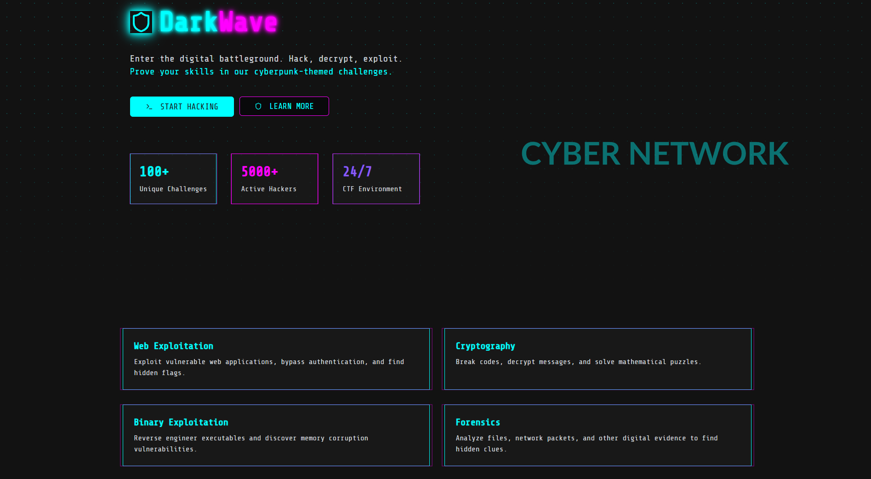
Fig.5.1 Home Page

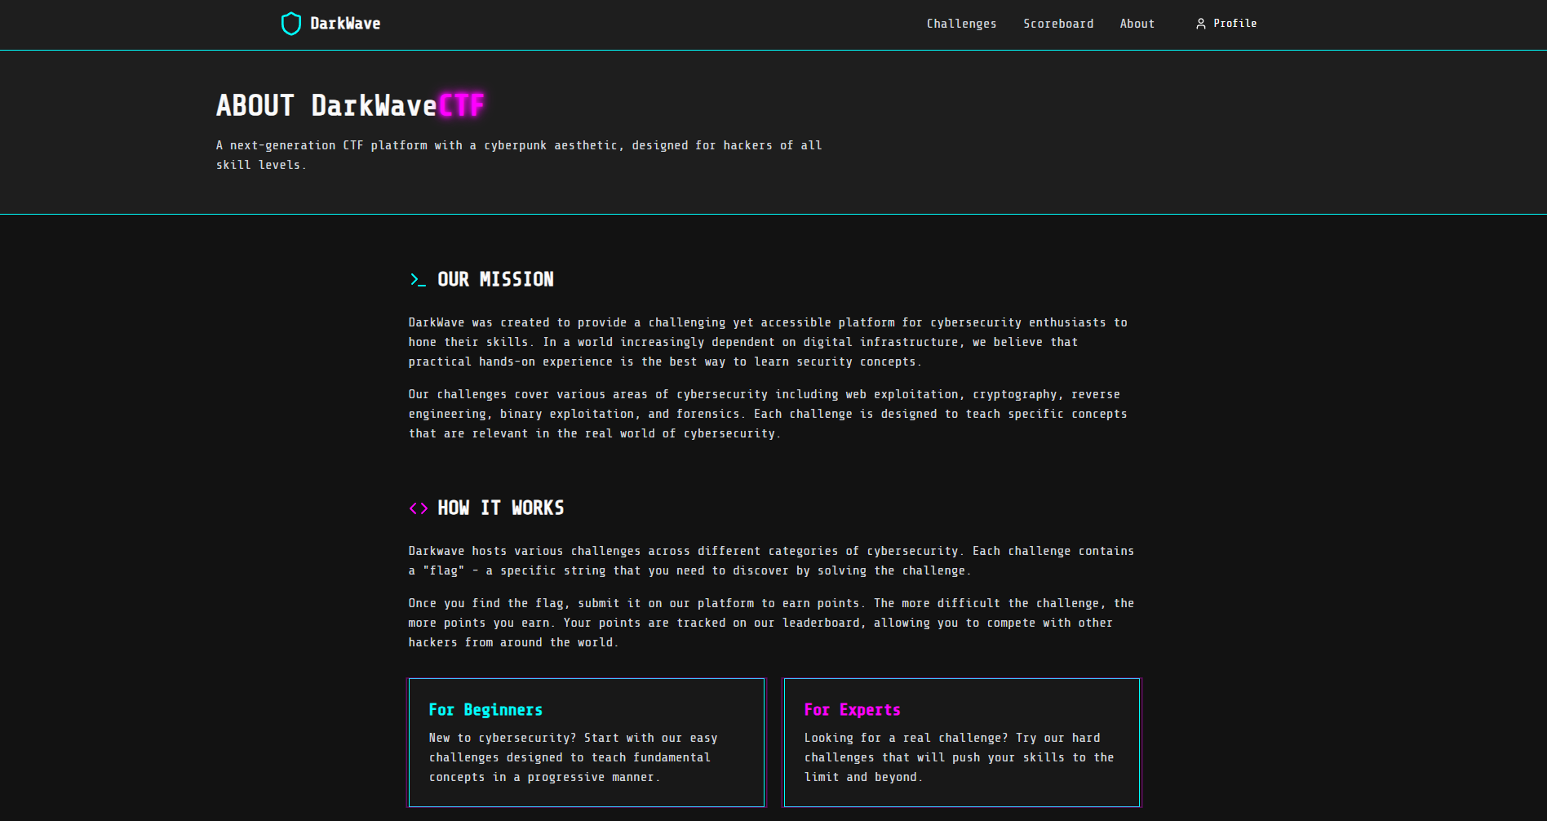
Fig.5.2 About Section
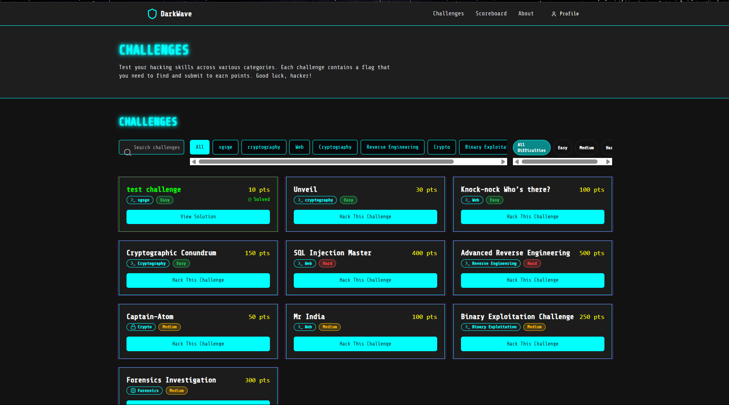
Fig.5.3 Challenges Page

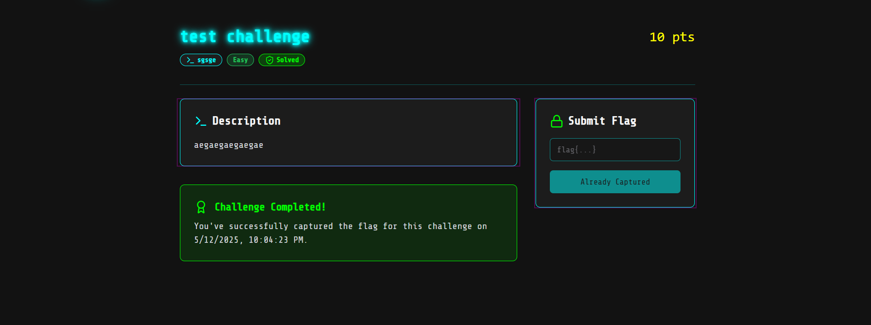
Fig.5.4 Challenge Card

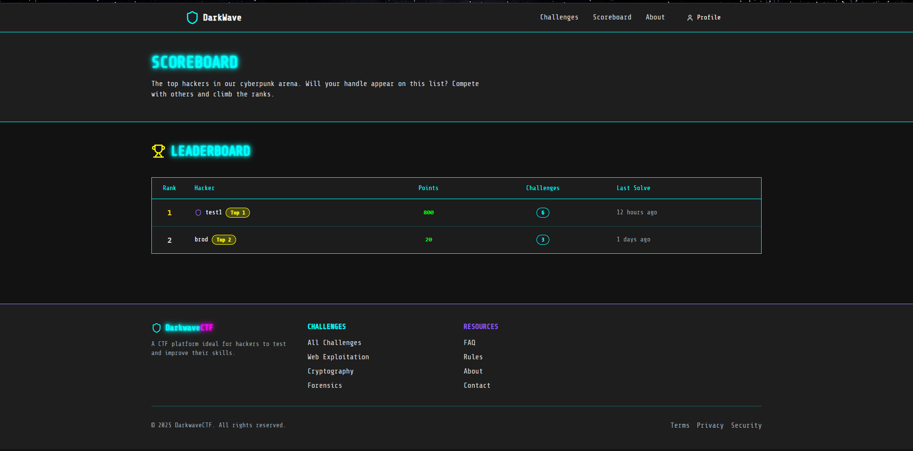
Fig.5.5 Leaderboard Page

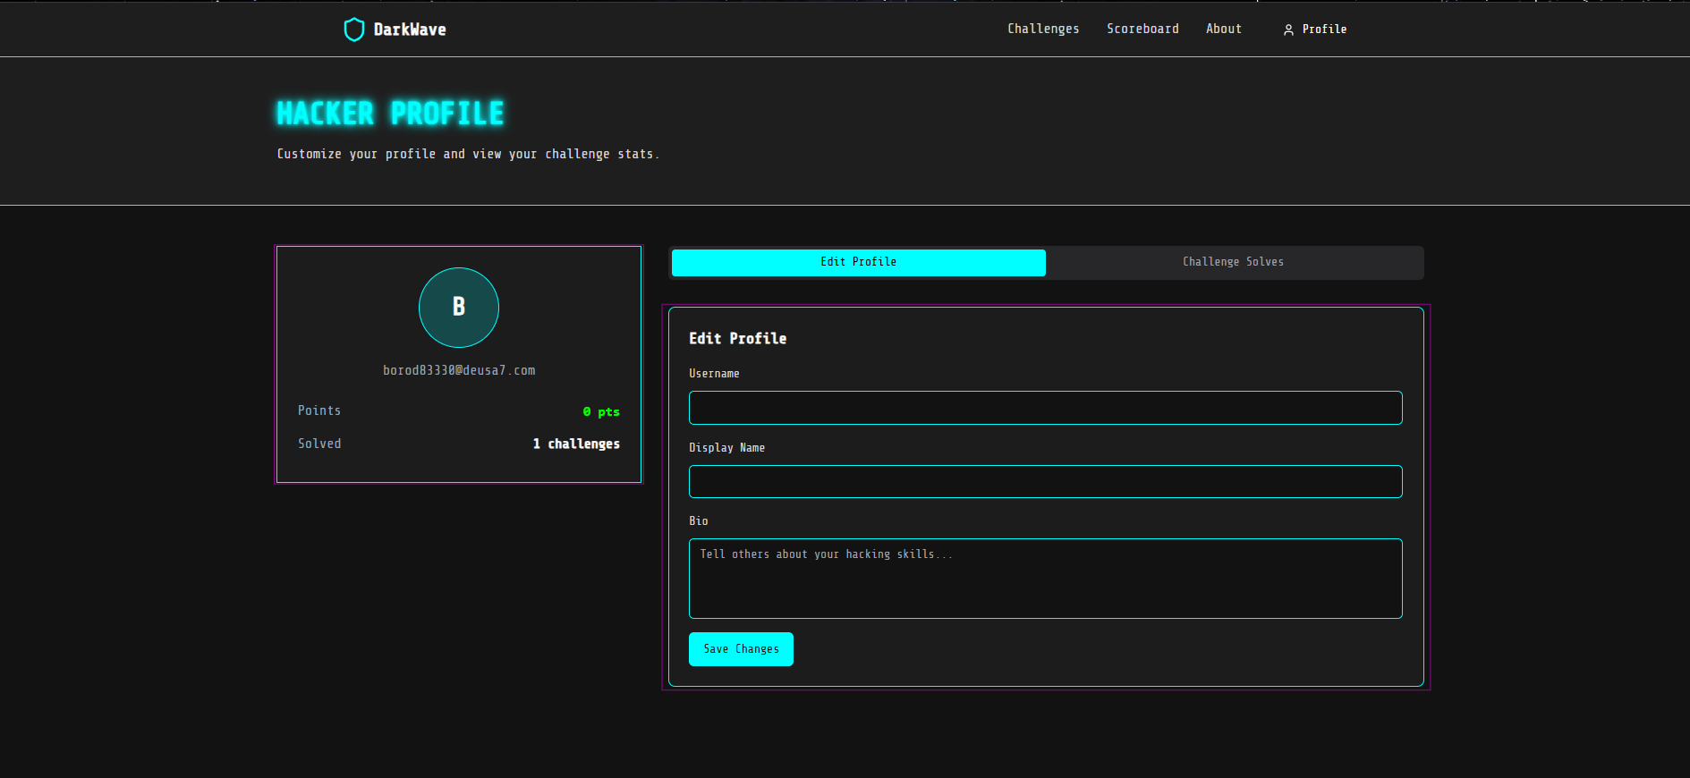
Fig.5.6 User Profile Page

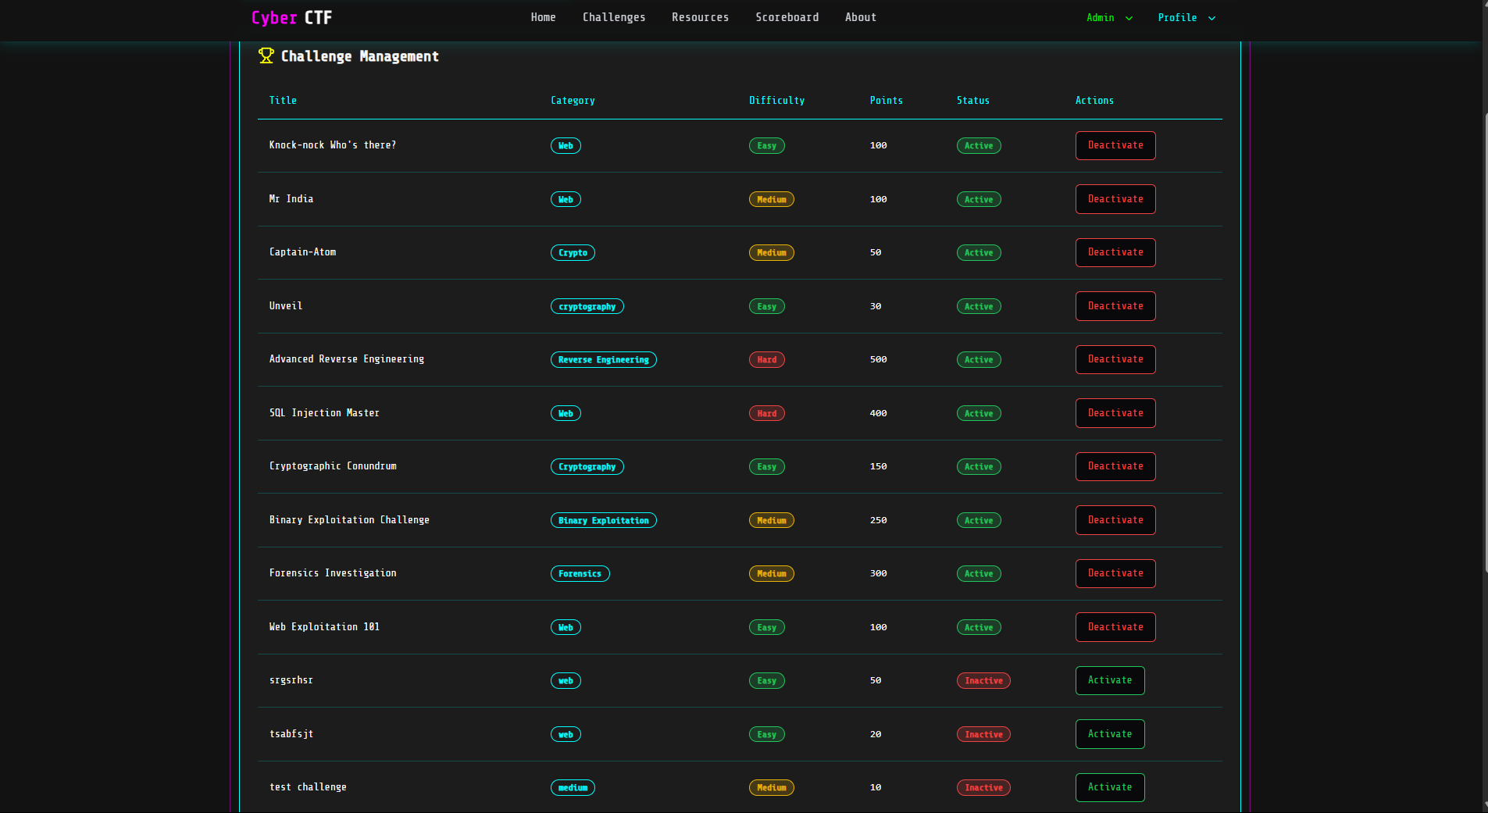
Fig.5.7 Challenge Management

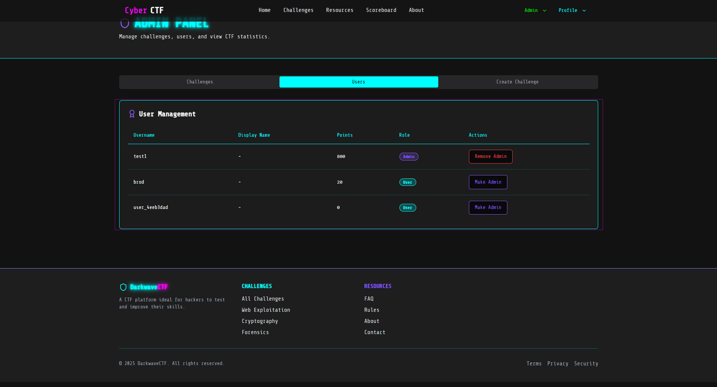
Fig.5.8 User Management

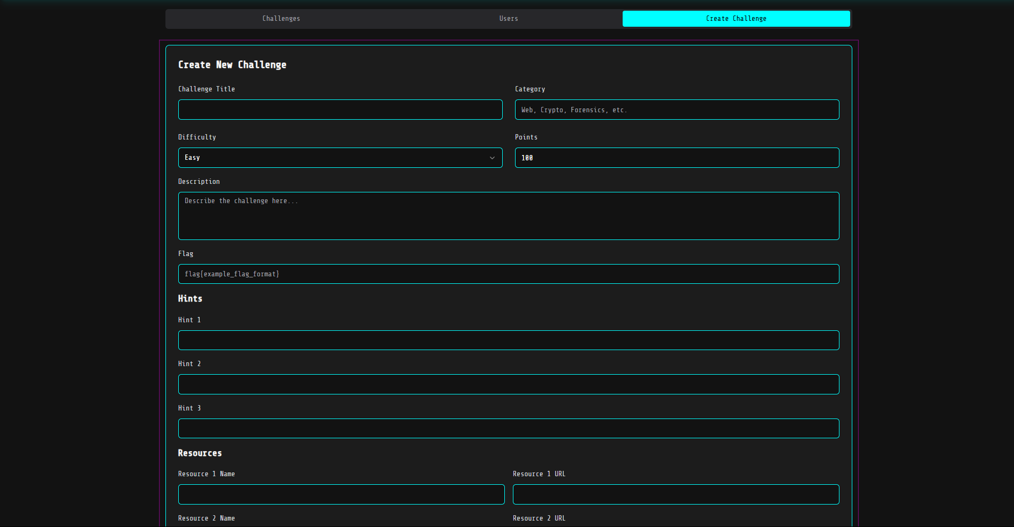
Fig.5.9 Challenge Creation
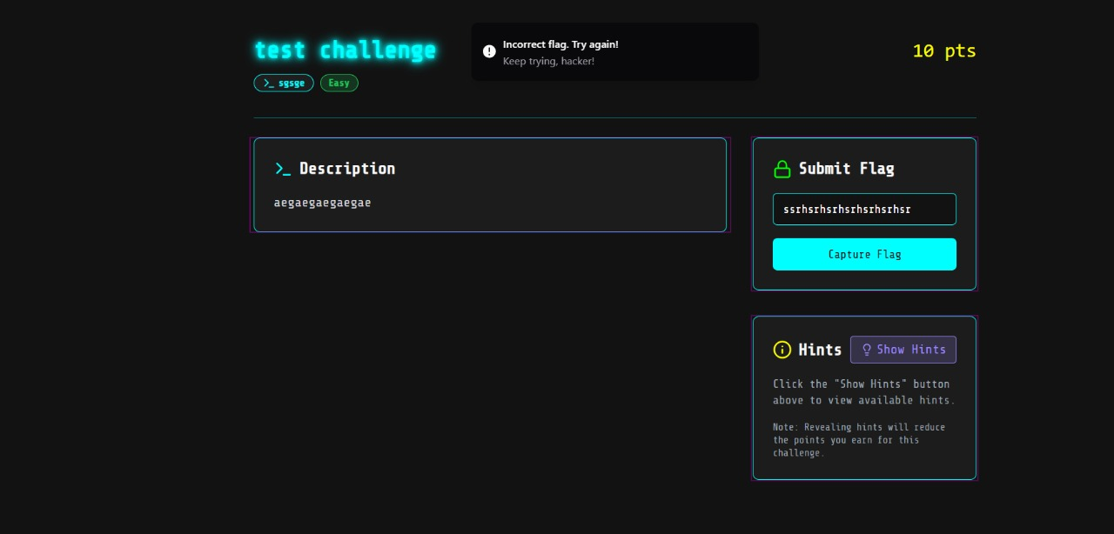
Fig.5.10 Incorrect Flag

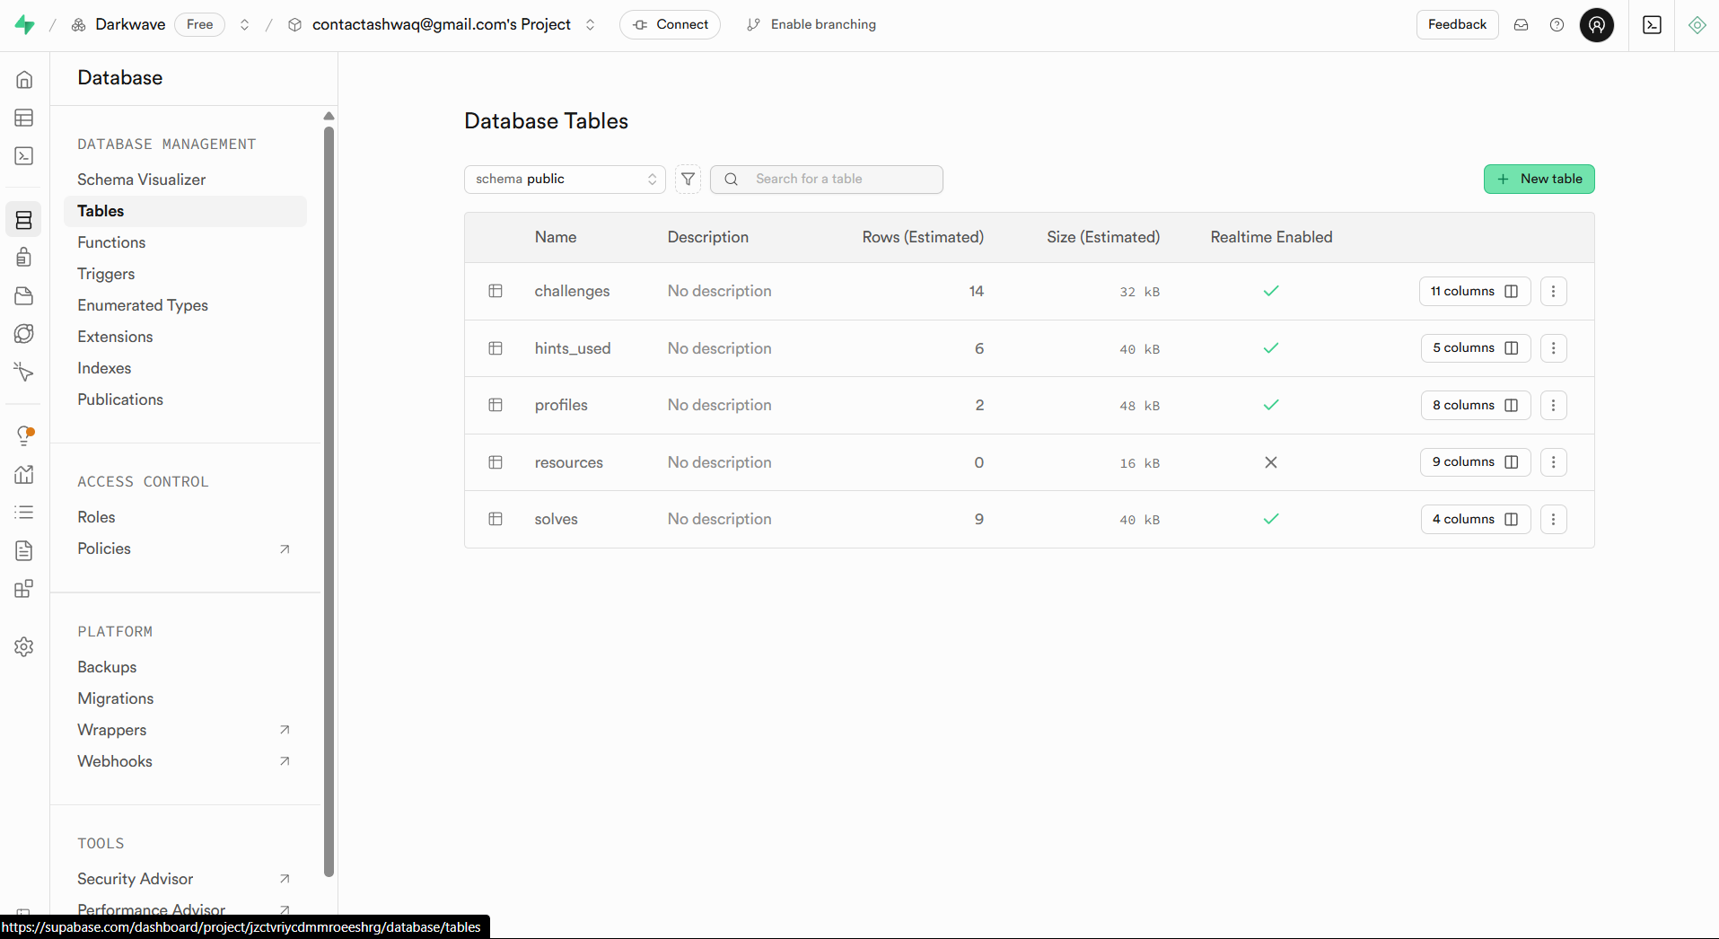
Fig.5.11 Supabase Dashboard

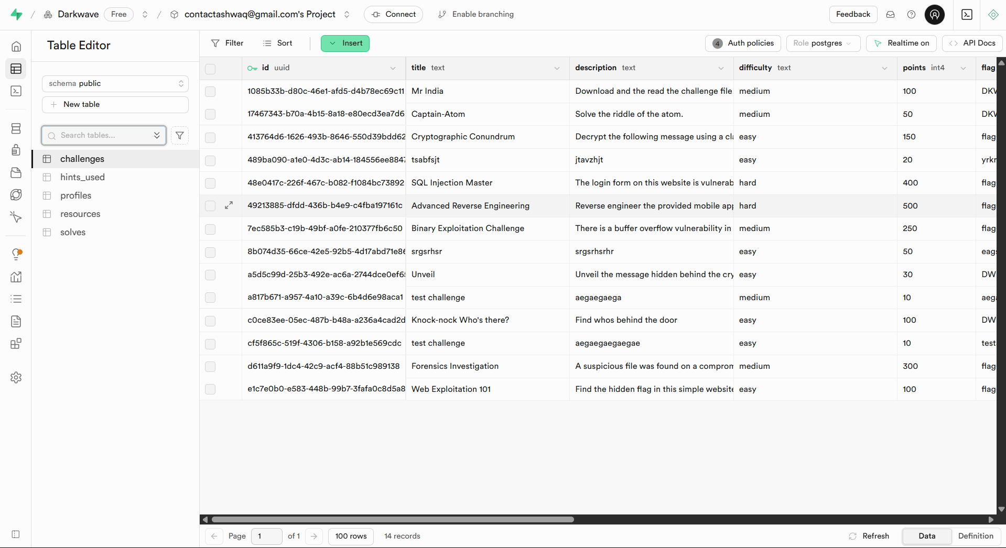
Fig.5.12 Table View

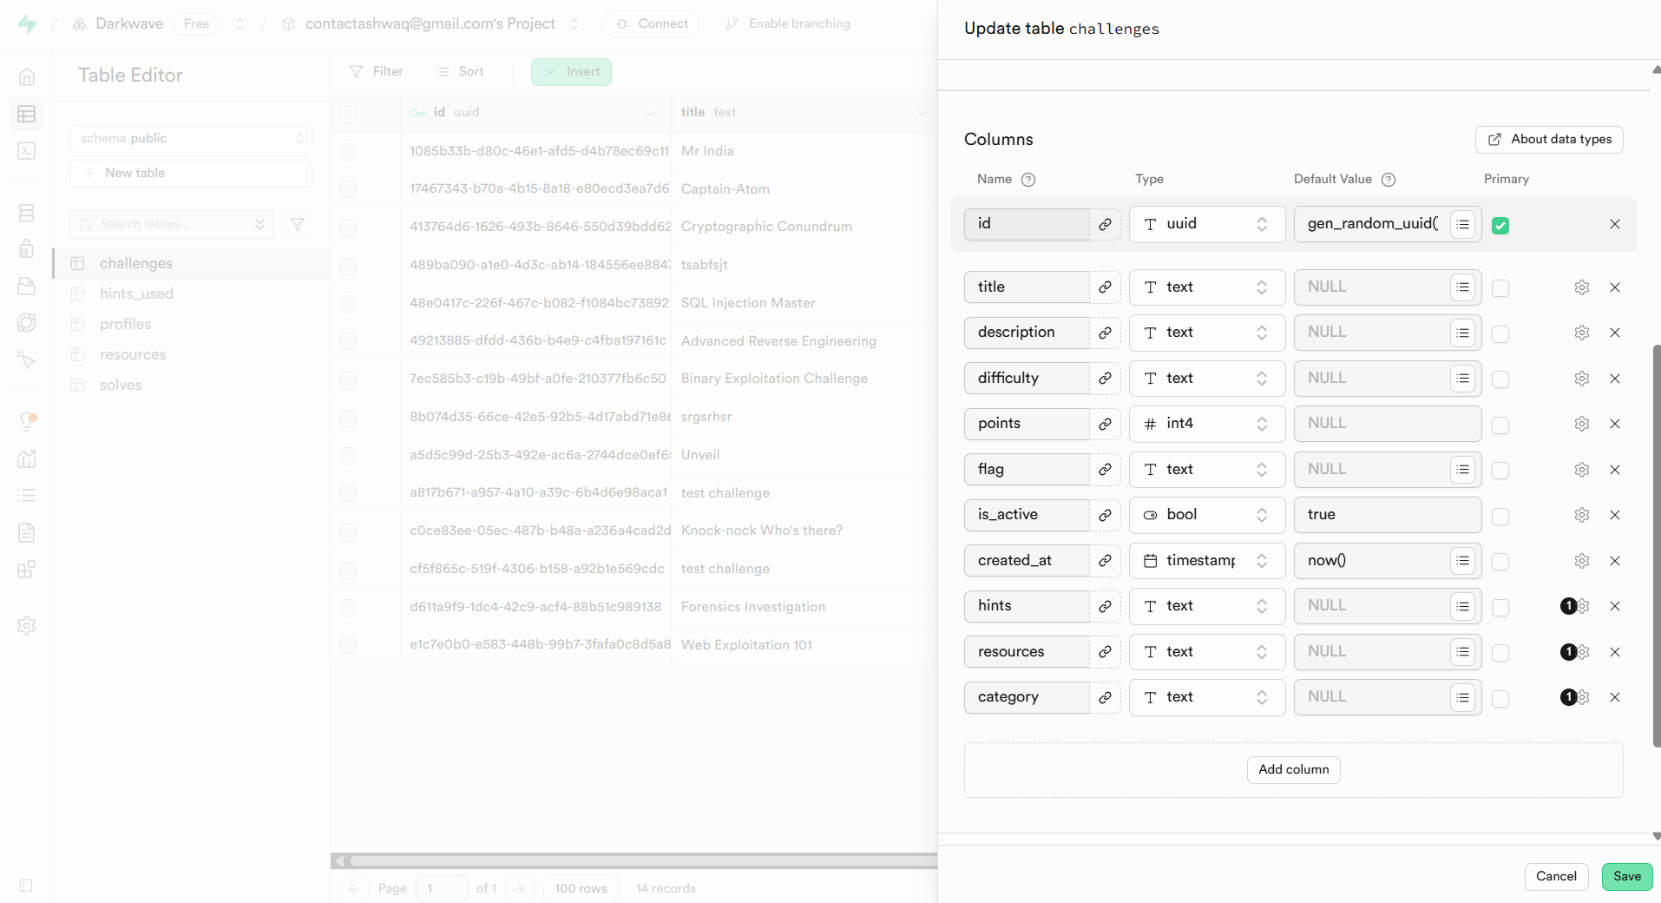
Fig.5.13 Table Configuration View

CONCLUSION & REFERENCES

6.1 Conclusion
The project Darkwave was successfully designed and developed as a robust, secure, and scalable web-based platform focused on cybersecurity education and competitive CTF challenges. It showcases the potential of modern web technologies and security-first development in addressing real-world cybersecurity learning needs. Darkwave not only meets its technical objectives but also fosters community-driven learning and ethical hacking practices.
Key Takeaways from the Development of Darkwave:
- Built using React and TypeScript: Delivers a modular, maintainable, and type-safe frontend experience for participants and organizers.
- Used Supabase (PostgreSQL) for backend: Offers scalable data storage, real-time capabilities, and secure user management.
- Challenge Management: Admins and organizers can create, categorize, and manage CTF challenges with intuitive dashboards.
- Player Dashboard: Users can register, track their progress, view rankings, and access hints in a gamified and responsive interface.
- Scoring System: Implements dynamic scoring, leaderboard functionality, and challenge weightage for fair competition.
- Security Education: Provides writeups, walkthroughs, and cybersecurity tutorials to promote ethical hacking practices.
- Secure Infrastructure: Incorporates role-based access, input validation, file upload restrictions, and follows OWASP Top 10 standards.
- Thorough Testing: Conducted manual testing, unit testing, and vulnerability assessments to ensure platform stability and integrity.
- Scalability Ready: Engineered to support future features like team play, timed events, and advanced analytics.
- UI/UX Design: Designed with mobile responsiveness, accessibility, and dark/light themes to enhance user experience.
Darkwave offers a holistic cybersecurity training ground that merges learning with competition. It validates the use of agile development, full-stack integration, and security-by-design methodologies in building impactful educational platforms. As a contribution to the cybersecurity ecosystem, Darkwave empowers learners, educators, and professionals to collaborate in a secure and engaging environment.

Future Scope
- Team-Based Competitions
  - Enable team registrations, collaborative solving, and real-time teamwork tracking features.
- Timed Events and Live CTFs
  - Host time-bound challenges with automated start/stop control for live contests and hackathons.
- Hint Economy / Token System
  - Introduce a point or token-based system for hint access to balance competition with learning.
- CTF-as-a-Service Model
  - Allow schools, colleges, and organizations to host their own CTFs using Darkwave infrastructure.
- Mobile App Integration
  - Develop companion mobile apps to allow on-the-go participation and notifications.
- AI-Powered Challenge Recommendations
  - Use machine learning to suggest challenges based on past attempts and skill levels.
- Advanced Analytics
  - Provide insights into challenge difficulty, solve rates, and player performance trends.
- Gamification Features
  - Add badges, levels, and achievement systems to motivate continuous learning.
- Community Forums
  - Build secure discussion areas for solution sharing, technical questions, and writeups.
- Partnership with Academia
- Collaborate with institutions to incorporate Darkwave into their cybersecurity curriculum.

Recommendations
- Maintain compliance with OWASP Top 10, especially when expanding user-generated content and challenge uploads.
- Implement CI/CD pipelines with rollback support to streamline deployments and bug fixes.
- Collect user feedback frequently through surveys and integrate UI/UX improvements based on real usage.
- Ensure privacy and data protection by following GDPR and regional data handling guidelines.
- Plan for cloud hosting and CDN usage (e.g., AWS, GCP) to ensure scalability during large CTF events.

6.2 References
- OWASP Security Guidelines
For best practices in secure platform development.
URL: https://owasp.org/www-project-top-ten/
- React TypeScript Cheatsheets
For building robust, type-safe UI components.
URL: https://react-typescript-cheatsheet.netlify.app
- Supabase Documentation
For backend, PostgreSQL, and real-time features.
URL: https://supabase.com/docs
- Firebase Authentication Guides (YouTube)
Channels like Fireship and Academind were used for secure login systems.
URL Example: https://www.youtube.com/watch?v=PKwu15ldZ7k
- MDN Web Docs
For JavaScript, HTML/CSS standards, and frontend references.
URL: https://developer.mozilla.org/
- Figma Community Files
For UI/UX prototyping, wireframing, and visual consistency.
URL: https://www.figma.com/community
- Testing Tools Documentation (Jest & Mocha)
For frontend and backend unit testing and integration validation.
URLs:
  - Jest: https://jestjs.io/
  - Mocha: https://mochajs.org/
- Burp Suite & OWASP ZAP
Used for penetration testing and vulnerability detection.
URLs:
  - Burp: https://portswigger.net/burp
  - ZAP: https://www.zaproxy.org/docs/
- GitHub Documentation
For version control, collaboration, and code history.
URL: https://docs.github.com/en

6.3 Appendices

A. Sample API Responses
// Sample: Challenge Data Response
{
"challenge_id": "c12567",
"title": "SQLi Login Bypass",
"category": "Web Exploitation",
"difficulty": "Medium",
"points": 200,
"author": "admin_darkwave",
"solves": 78
}
[
{
"username": "alice_wizard",
"score": 1200,
"rank": 1
},
{
"username": "bob_ctf",
"score": 950,
"rank": 2
},
{
"username": "charlie_root",
"score": 800,
"rank": 3
}
]
// Sample: Authentication Response
{
"user_id": "player_0245",
"username": "cyberhawk",
"role": "player",
"token": "eyJhbGciOiJIUzI1NiIsInR5cCI6Ikp..."
}

B. Security Summary
- Authentication: Secure login with Firebase Authentication or Supabase Auth.
- Authorization: Role-based controls for players, organizers, and admins.
- Input Sanitization: Protects against injection attacks and XSS.
- Secure Uploads: Challenge files are validated and securely stored.
- OWASP Guidelines: Backend routes and user inputs follow OWASP Top 10.

C. Technology Stack Overview
- Frontend: React.js + TypeScript + Tailwind CSS
- Backend: Supabase (PostgreSQL)
- Authentication: Firebase Auth or Supabase Auth
- Testing: Jest (Frontend), Mocha (Backend)
- Security Testing: Burp Suite, OWASP ZAP
- Version Control: GitHub (Private Repos)
D. Future Scope
1. Enhanced User Authentication and Authorization
Multi-Factor Authentication (MFA)
- Implement 2FA (Two-Factor Authentication) for added security during login, which is especially critical for users handling sensitive or high-value data.
Role-Based Access Control (RBAC)
- Introduce role-based features where certain users (e.g., admins or moderators) can manage challenges, track participant activity, or reset user progress.
- Admins can moderate flag submissions, view detailed analytics, and manage challenges.
OAuth Integration
- Allow users to sign up and log in via external OAuth providers like GitHub, Google, or Facebook, making the process quicker and user-friendly.

2. Dynamic Challenge Creation and Management
User-Generated Challenges
- Enable users to create their own challenges, either publicly or privately, through a simple admin panel. This can be useful in gamifying the platform by allowing users to contribute their knowledge.
Dynamic Difficulty Adjustment
- Based on the average time it takes to solve a challenge, adjust its difficulty rating dynamically. Challenges that take longer than usual to complete could be tagged as harder, while easy challenges could be moved to beginner levels.
Challenge Hints & Timed Hints
- Provide hint systems that can be unlocked by users for solving challenges. Hints could be time-based (e.g., hints unlock after a certain time has passed) or activity-based (e.g., after a set number of incorrect attempts).

3. Real-Time Interactivity
Real-Time Leaderboard
- Implement a live leaderboard where participants can see the rankings update in real-time as they and others solve challenges. This can be achieved using WebSockets for faster, live updates.
Instant Feedback on Flag Submission
- Allow for real-time validation of flag submissions where users receive immediate feedback (correct/incorrect flag, hints, or suggestions) without needing to refresh or wait for a server response.

4. Gamification & Rewards
Badges & Achievements
- Introduce a badge system that rewards users for achieving certain milestones, such as solving a set number of challenges, completing challenges in under a certain time, or participating in community events.
- Allow users to display their achievements on their profile, adding social proof and motivation.
Daily/Weekly Challenges
- Provide daily or weekly challenges that users can participate in for additional rewards. These could feature unique flags or puzzles that require new techniques or methodologies.

5. Advanced Scoring and Challenge Point System
Dynamic Point Allocation
- Introduce dynamic points for challenges, where the point value adjusts based on the difficulty of solving them, the number of solves, and the time taken to solve them.
Bonus Points for Speed
- Offer bonus points for solving challenges faster than others (e.g., users who solve a challenge in the first hour after it’s posted get extra points).

6. Collaboration Features
Team-Based CTF Competitions
- Allow users to form teams and work together on challenges, with a shared leaderboard for the team. Teams can submit flags collectively and track their progress together.
Private Challenges for Teams
- Allow teams to create and solve private challenges that are only visible to their members, which could be used for internal competitions, training, or testing.

7. Improved Analytics and Reporting
Advanced User Analytics
- Track and display detailed statistics about user performance, such as average time per challenge, accuracy rate, total attempts, and total score. This data could be displayed to users for feedback and progress tracking.
Challenge Analytics
- Provide analytics on each challenge, including how many users solved it, average solving time, and feedback on its difficulty, which can be used to adjust the challenge or make improvements.

8. Security and Anti-Cheat Measures
Flag Obfuscation
- Use flag obfuscation techniques to make it harder for users to guess or brute-force flags, such as encoding the flags or using randomization techniques.
Challenge Integrity
- Implement measures to prevent cheating in challenges, such as logging user actions, detecting suspicious behaviors, or restricting challenge access after a set time limit to prevent unfair advantage.
CAPTCHA Implementation
- Integrate CAPTCHA mechanisms to avoid bots and scripts from submitting flags automatically, ensuring fair play and authentic participation.
9. Platform Scalability
Distributed Hosting
- Implement cloud hosting solutions like AWS, Google Cloud, or Azure to scale the backend dynamically based on demand, ensuring the platform remains responsive and stable as user numbers increase.
Database Sharding
- Use database sharding or partitioning strategies to optimize storage and retrieval of large amounts of challenge data, leaderboard statistics, and user information.
Rate Limiting
- Implement rate limiting on the API to protect against DoS attacks or misuse by ensuring that users can only make a certain number of requests per minute.

10. Mobile and Multi-Platform Support
Mobile App
- Develop a mobile app for the CTF platform, allowing users to participate in challenges, view the leaderboard, and track their progress directly from their phones. This could be a native app or a Progressive Web App (PWA).
Offline Participation
- Enable users to download challenges for offline participation. Once they have solved challenges offline, they can submit their flags once they’re back online.

11. Integration with External Platforms
Integration with Online Learning Platforms
- Partner with online learning platforms (e.g., Coursera, Udemy) to offer CTF-related courses or certifications for solving challenges, creating a deeper learning experience for users.
CTF Event Integration
- Integrate the platform with major CTF events or create partnerships to host official CTF competitions and earn recognition for solving challenges on the international stage.
12. Community and Social Features
Discussion Forum
- Add a discussion forum for each challenge, allowing users to discuss techniques, strategies, or hints without spoiling the solution.
Mentorship Program
- Introduce a mentorship or tutoring system, where experienced users or challenge creators can help newcomers, providing guidance without giving direct solutions.

